Name _________________________________________ Date _______________

**Unit 8 Review**

**For problems 1-12, decided if the functions are even, odd, or neither.**

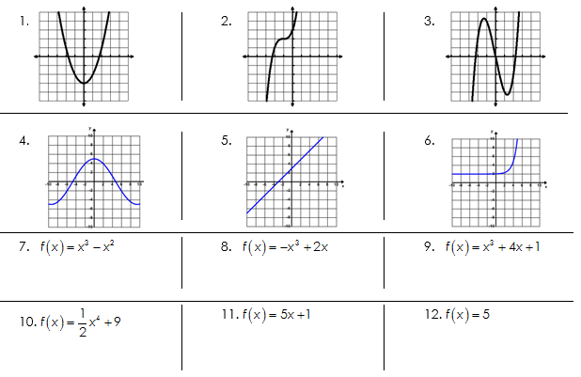

**Fill in the chart describing the differences in each type of function.**

|  |  |  |  |
| --- | --- | --- | --- |
| **Name of Function** | **Equation** | **Key characteristics** | **Sketch of the graph** |
| Linear |  |  |  |
| Quadratic |  |  |  |
| Exponential |  |  |  |

**Identify the following equations as linear, quadratic or exponential.**

|  |  |
| --- | --- |
| **1.** | **2.** |
| **3.** | **4.** |
| **5.** | **6.** |
| **7.** | **8.** |
| **9.** | **10. $f\left(x\right)={\left(x-2\right)}^{2}+7$** |

1. Look at the following tables and decide if they represent a linear, exponential, or quadratic function.

|  |  |
| --- | --- |
| **x** | **y** |
| -4 | 5 |
| -3 | 8 |
| -2 | 13 |
| -1 | 20 |
| 0 | 29 |
| 1 | 40 |

|  |  |
| --- | --- |
| **x** | **y** |
| -5 | 32 |
| -4 | 16 |
| -3 | 8 |
| -2 | 4 |
| -1 | 2 |
| 0 | 1 |

|  |  |
| --- | --- |
| **x** | **y** |
| 0.5 | 0.9 |
| 0.75 | 1.1 |
| 1 | 1.3 |
| 1.25 | 1.5 |
| 1.5 | 1.7 |
| 1.75 | 1.9 |

|  |  |
| --- | --- |
| **x** | **y** |
| -2 | -2.75 |
| 0 | -2 |
| 2 | 1 |
| 4 | 13 |
| 6 | 61 |
| 8 | 253 |

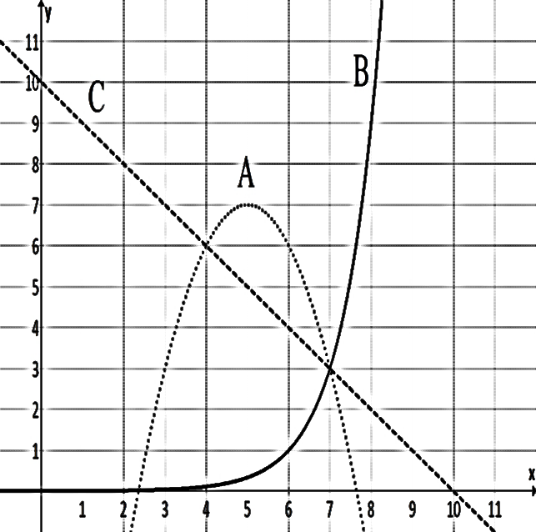Use the following graph to answer the following questions:

Which function is linear? Exponential? Quadratic?

List the functions in order from smallest to largest based on x-intercepts:

List the functions in order from smallest to largest based on y-intercepts:

List the functions in order from smallest to largest when x = 2:

List the functions in order from smallest to largest when x = 5:

List the functions in order from smallest to largest when x = 9:

List the functions in order from smallest to largest when x = 15:

Which functions have a positive rate of change through the entire graph?

Which functions have a negative rate of change through the entire graph?

Which function has a rate of change that can be both positive and negative?

Which functions go towards negative infinity as x goes towards infinity?

Which functions go towards positive infinity as x goes towards infinity?