Unit 6.2 Review – Converting and Applications of Quadratics

Convert from Standard to Vertex Form:

1.  2. 
2.  4. 

Convert from Vertex to Standard Form:

1. ** 2. **
2.  4. 

Application:

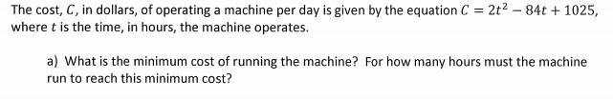1.

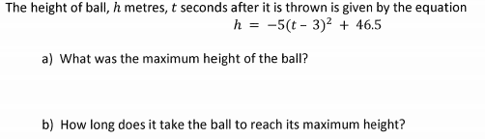2.

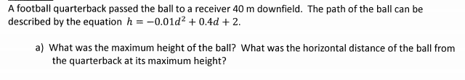3.

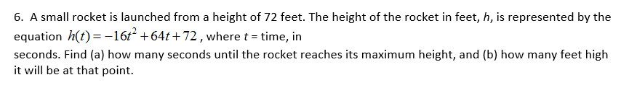

4.