Unit 6.1 Review – Transformations, Graphing, and Characteristics

Determine the Transformations and Vertex:

1.  2.  3. 

Graph the following in vertex form:

1. 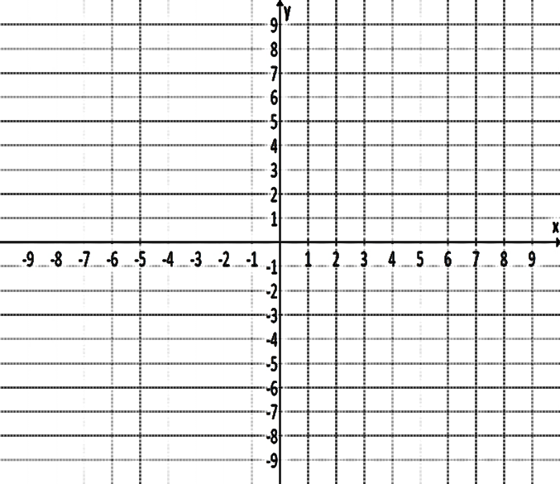
2. 

Graph the following in standard form:

1. 



1. 
2. 

Characteristics of Graphs:

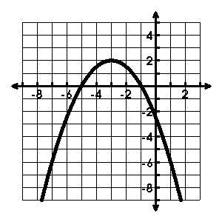

Vertex: ______________ Axis of Symmetry:________________

Max/Min Value: ____________

Y-Intercept: ______________ Zeroes: ____________________

Domain: _________________ Range: _____________________

Interval of Increase:________________________________________

Interval of Decrease:_______________________________________

End Behavior: as x 🡪 -∞, f(x) 🡪 ______; as x 🡪 ∞, f(x) 🡪 _______

Rate of change on the interval -1 < x< 0:____________________

**Vertex: ______________ Axis of Symmetry:________________**

**Interval of Increase:________________________________________**

**Interval of Decrease:_______________________________________**

**Extrema: ________________ Max/Min Value: ____________**

**Domain: _________________ Range: _____________________**

**Y-Intercept: ______________ Zeroes: _____________________**

**Rate of change on the interval -3 < x< 0:____________________**

**Vertex: ______________ Axis of Symmetry:________________**

**Interval of Increase:________________________________________**

**Interval of Decrease:_______________________________________**

**Extrema: ________________ Max/Min Value: ____________**

**Domain: _________________ Range: _____________________**

**Y-Intercept: ______________ Zeroes: _____________________**

**Rate of change on the interval -3 < x< 0:____________________**

Between what x-values is the graph negative? ________________

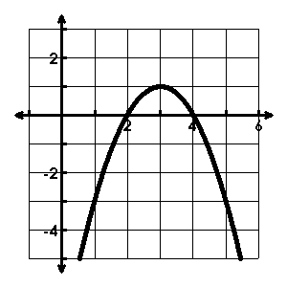

Vertex: ______________ Axis of Symmetry:________________

Max/Min Value: ____________

Y-Intercept: ______________ Zeroes: ____________________

Domain: _________________ Range: _____________________

Interval of Increase:________________________________________

Interval of Decrease:_______________________________________

End Behavior: as x 🡪 -∞, f(x) 🡪 ______; as x 🡪 ∞, f(x) 🡪 _______

Rate of change on the interval 1 < x< 3:_____________________

Between what x-values is the graph positive? ________________