**Brain Dump:** List the first 15 perfect squares:

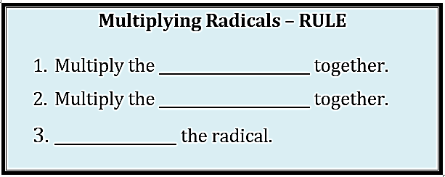 

**Simplify Practice:** Answer the following.

a.  b.  c.  d.  e. 

f.  g.  h.  i. 

j.  k.  l.  m. 

**Multiply Practice:** Multiply the following radicals. Make sure they are in simplest form.

a.  b.  c. 

d.  e.  f. 

**Add/Subtract Practice:** Add or Subtract the following radicals. Make sure they are in simplest form.

a.  b.  c. 

d.  e.  f. 

g.  h.  i. 

**Putting It All Together:** Put together everything you have learned about radicals.

a.  b.  c. 

d.  e.  f. 

**Rational vs Irrational**: Classify each number as rational or irrational and explain why.

a.  b. ¼ c. 

d.  e.  f. 

g. (2 + 5) h.  i. 4()

**Critical Thinking:**

Let the following variables represent a certain type of number:

**A** = 5 **B** = -5 **C** = 

**D** =  **E** = **F** = 

Determine if the following sums or products will result in a rational or irrational number.

a. A + B b. A + C c. C + D d. C + F

e. A x B f. B x C g. C x D h. C x C

i. D + E j. D x E k. E + F l. B + F

