Algebra 1 Name:____________________________________
Unit 2 Review Date:________________________ Block:________

What you need to know & be able to do | Things to remember | Examples
Determine if a relation is a function. | Every input only has one output (each ‘x’ only has one ‘y’)  Use the vertical line test on graphs. | 1. Determine if the graph is a function.  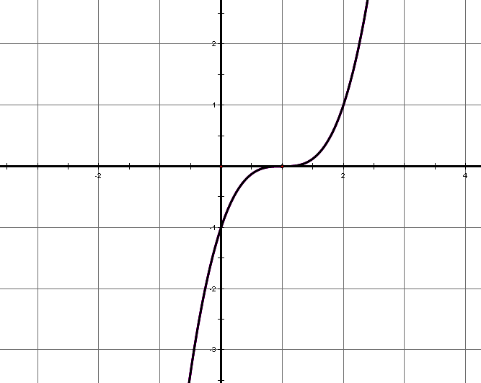 | 2. Determine if the table represents a function.
  x | y
  -1 | 4
  0 | 5
  2 | 6
  -1 | 7
Evaluate functions. | f(x) function notation  f(2) means you must substitute a ‘2’ for every ‘x’ in the function! | 3. Evaluate f(4). | 4. Find the value of  when .
5. Find the value of f(5).
6. Find the value of x for f(x)=2.
7. Identify the maximum and minimum in function notation.
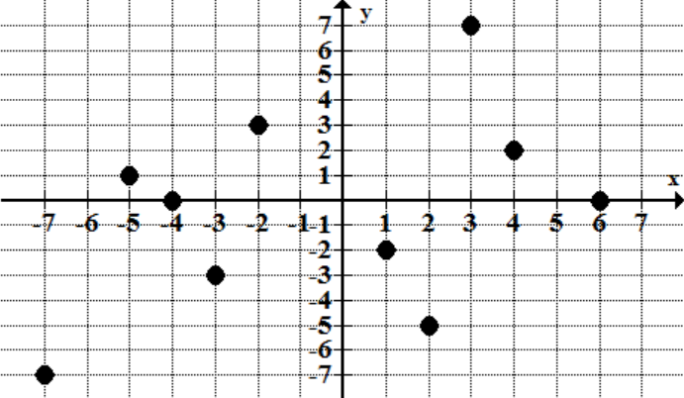
Graph a linear function. | *Always graph the y-intercept first! | 8. Graph:   | 9. Graph:
 |  | 10. Graph: | 11. Graph: 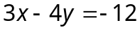
Graph a linear inequality. | Dashed line:  Solid line:  *Don’t forget to shade! | 7. Graph: | 8. Graph:
 |  | 9. Graph:
Identify important characteristics of a function. | x-intercept(s): where the graph crosses the x-axis.  y-intercept(s): where the graph crosses the y-axis.  maximum/minimum: the highest or lowest points.  Domain: input, x-values  Range: output, y-values  Increase: where the graph looks like it’s going “up hill”.  Decrease: where the graph looks like it’s going “down hill”.  Constant: where the graph is horizontal.  End-Behavior:  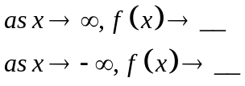 | 10.   | 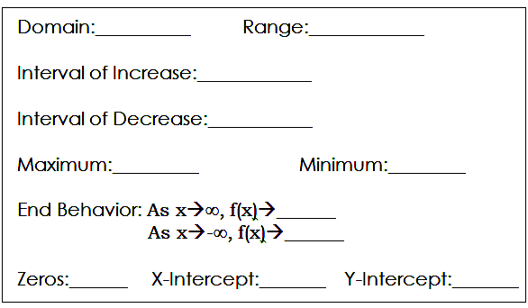
Identify important characteristics of a function. |  | 11. | 12.
Calculate the average rate of change. | “slope”  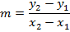 | 13. What is the average rate of change from x=0 to x=4?   | 14. Which function has the greater rate of change?  Function 1: y = 2x + 3  Function 2: (0, 4), (1, 8), (2, 12)
 |  | 15. The table to the right shows the distance (in meters) Runner A and Runner B ran at different time intervals. Which runner has a faster average speed from 20 to 31 seconds? | 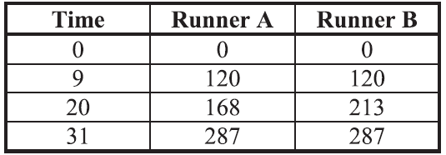
Write the equation of a line. |  | 16. Write the equation of the line that has a slope of and contains the point (4, 6). | 17. Write the equation of the line that contains the points  (-2, 2) and (2, -2).
Write the equation of a line. |  | 18. Write the equation of the line that is parallel to the line and contains the point (1, 5). | 19. Write the equation of the line that is perpendicular to the line and contains the point (0, 11).
 |  | 20. Write the equation of the line that has a slope of 5 and  y-intercept at (0, 3). | 21. Write the equation of the line the corresponds to the following table:
  x | 2 | 5 | 8 | 11
  y | -6 | -4 | -2 | 0
 |  | 22. Write the equation of the line that corresponds to the graph below: 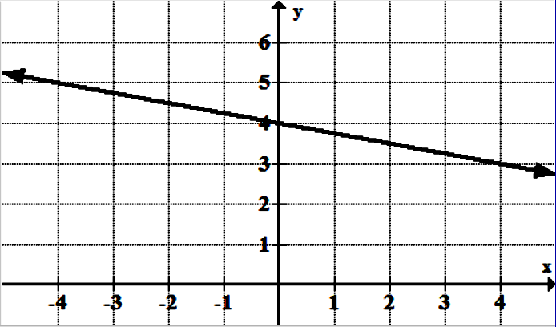
Arithmetic Sequences | Explicit form:  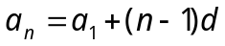  Recursive form:  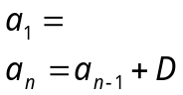 | 23. Write the EXPLICIT and RECURSIVE formula for the following sequence:  5, 9, 13, 17… | 24. Write the EXPLICIT and RECURSIVE formula for the following sequence:  -3, -8, -13, -18…
 |  | 25. Given the sequence -3, 0, 3, 6… find the following term values:  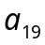= 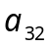= | 26. Given the sequence 7, 15, 23, 31… find the following term values:  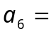 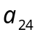=
 |  | 27. Determine the first four terms of the sequence:  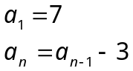 | 28. Determine the first four terms of the sequence:  

