2.2

|  |  |  |  |
| --- | --- | --- | --- |
| **What you need to know & be able to do** | **Things to remember** | **Examples** | |
| Determine if a relation is a function. | Every input only has one output (each ‘x’ only has one ‘y’)  Use the vertical line test on graphs. | 1. Determine if the graph is a function. | 2. Determine if the table represents a function.   |  |  | | --- | --- | | **x** | **y** | | -1 | 4 | | 0 | 5 | | 2 | 6 | | -1 | 7 | |
| Evaluate functions. | f(x) function notation  f(2) means you must substitute a ‘2’ for every ‘x’ in the function! | 3. Evaluate f(4). $$f\left(x\right)=x^{2}+3x-1$$ | 4. Find the value of $f\left(x\right)=4x-2$ when $x=-1$. |
| 5. Find the value of f(5).  6. Find the value of x for f(x)=2.  7. Identify the maximum and minimum in function notation. | | | |
| Write the equation of a line. | $$y-y_{1}=m(x-x_{1})$$ | 8. Write the equation of the line that has a slope of $-\frac{1}{2}$ and contains the point (4, 6). | 9. Write the equation of the line that contains the points  (-2, 2) and (2, -2). |
| 10. Write the equation of the line that is parallel to the line $y=-4x-1$ and contains the point (1, 5). | 11. Write the equation of the line that is perpendicular to the line $y=3x+2$ and contains the point (0, 11). |
|  |  | 12. Write the equation of the line that has a slope of 5 and  y-intercept at (0, 3). | 13. Write the equation of the line the corresponds to the following table:   |  |  |  |  |  | | --- | --- | --- | --- | --- | | x | 2 | 5 | 8 | 11 | | y | -6 | -4 | -2 | 0 | |
|  |  | 14. Write the equation of the line that corresponds to the graph below: | |

**Determine if the following is a relation or a function.**

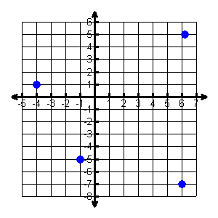15. 16.  17.

|  |  |  |
| --- | --- | --- |
| Input |  | Output |
| -6 |  | -13 |
| -1 |  | -7 |
| 4 |  | -2 |
| 2 |  |  |
| 9 |  | 3 |