2.1

|  |  |  |  |
| --- | --- | --- | --- |
| Graph a linear function. | $$y=mx+b$$*Always graph the y-intercept first! | 1. Graph:  graph.bmp | 2. Graph:  graph.bmp |
|  |  | 3. Graph:  graph.bmp | 4. Graph:  graph.bmp |
| Graph a linear inequality. | Dashed line: $<or>$ Solid line: $≤or≥$ *Don’t forget to shade! | 5. Graph:  graph.bmp | 6. Graph:  graph.bmp |
|  |  | 7. Graph:  graph.bmp |  |
| Identify important characteristics of a function. | x-intercept(s): where the graph crosses the x-axis.  y-intercept(s): where the graph crosses the y-axis.  maximum/minimum: the highest or lowest points.  Domain: input, x-values  Range: output, y-values  Increase: where the graph looks like it’s going “up hill”.  Decrease: where the graph looks like it’s going “down hill”.  Constant: where the graph is horizontal.  End-Behavior: | 8.  graph.bmp |  |
| 9.  graph.bmp | 10.  graph.bmp |
| Calculate the average rate of change. | “slope” $$m=\frac{y_{2}-y_{1}}{x_{2}-x_{1}}$$ | 11. What is the average rate of change from x=0 to x=4?  graph.bmp | 12. Which function has the greater rate of change?  Function 1: y = 2x + 3  Function 2: (0, 4), (1, 8), (2, 12) |
|  |  | 13. The table to the right shows the distance (in meters) Runner A and Runner B ran at different time intervals. Which runner has a faster average speed from 20 to 31 seconds? |  |

[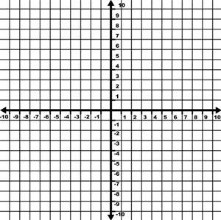](http://www.bing.com/images/search?q=quadrant+plane&view=detailv2&&id=620DFBE0025D65E653B244A8C2B0D69BF048B507&selectedIndex=162&ccid=jLtrWH4j&simid=608014920123682033&thid=OIP.M8cbb6b587e23b1ef07d6a11aab29fd0fH0)

14. Identify the slope and y-intercept of the following then graph

y = 2x – 3 m =__________ b = ___________

[](http://www.bing.com/images/search?q=quadrant+plane&view=detailv2&&id=620DFBE0025D65E653B244A8C2B0D69BF048B507&selectedIndex=162&ccid=jLtrWH4j&simid=608014920123682033&thid=OIP.M8cbb6b587e23b1ef07d6a11aab29fd0fH0)15. Graph 2x – 4y < 8

16. Find the slope for the following 2 point (2, 4) and (5, 7)

17. Write the equation of the line going through the point (-2, 4) and (3, -2)