Unit 12 Review Guide
Data Analysis

1. Identify the following for the data of Johnny’s test scores:
92, 96, 97, 83, 92, 58, 93, 88, 77, 48, 65, 80, 71

Mean = ________ Mode = ________ Range = ________ IQR = ________ MAD = ________

Min = ________ Q1 = ________ Median = ________ Q3 = ________ Max = ________

Workspace:

2. Use the box plot below to answer the following questions regarding 36 students and their heights:
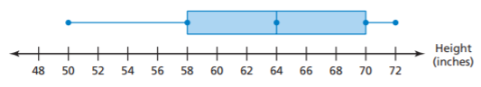

a. What percent of students had a height less than 70 inches?

b. What percent of students had a height between 58 and 64 inches?

c. How many students were taller than 50 inches?

d. How many students were between 64 and 70 inches?

e. Name the following: IQR = ________ Q3 = ________ 25th Percentile = ________

3. Answer the following:
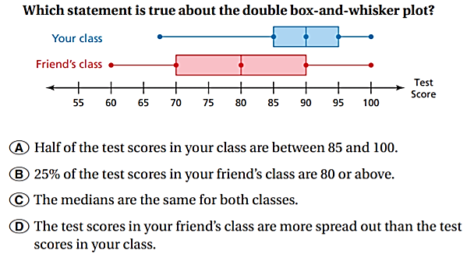
4. Answer the following using the dot plots:
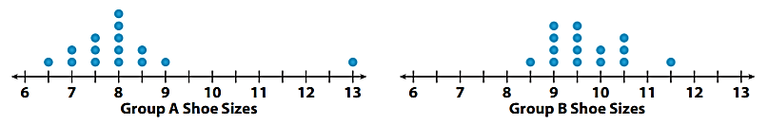

a. Which class has the bigger range? Explain how you determined your answer.

b. Which class has the bigger median? Explain how you determined your answer.

c. Which class has the bigger mean? Explain how you determined your answer.

5. Sally currently has a 94% average in the class. She has scored a 90, 97, 94, 92, and 95 on her assignments. She missed three days of school and receives 0’s on her assignments until she makes them up.

a. Explain how the zeros affect her overall grade average.

b. Which measure of central tendency would best describe her grades? Why?

6. Describe the type of distributions show below:

a. b. c.
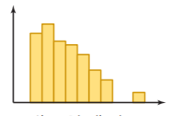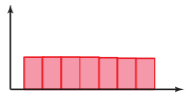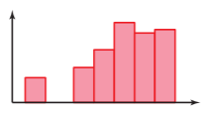

7. Describe the type of distribution each of the following scenarios would have. Then draw a rough sketch of the distribution OR explain your answer.

a. A really easy test b. Prices of car s for sell c. Peoples’ heights

d. The age people retire at e. A really hard test f. Age people wear braces

8. Use the histogram to answer the following questions about how long it takes students to get ready.
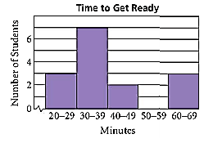
a. How many students answered the question?

b. How many students take less than 40 minutes to get ready?

c. Based on the info given, could you redraw the current histogram with intervals half their current size? Why or why not?

9. Use the chart on the right to answer the following. You must show your fraction!

1. What percent of students like drama movies?

2. What percent of students were from Class A?

3. What percent of students liked horror movies and were from Class B?

4. What percent of students in Class A liked comedies?

5. What percent of students, who liked drama movies, were from Class B?

