**Quadratic Transformations (all) Name: ____________________________**

**Practice Date Date: _______________ Block: _______: _______________ Block: _______**

# Describe the transformations of the parent graph for each equation. Then name vertex.

1. 
2. 
3. 

Vertex: ___________ Vertex: ___________ Vertex: ___________

1. 
2. 
3. 

Vertex: ___________ Vertex: ___________ Vertex: ___________

# Write the quadratic equation in vertex form that has been…

1. shifted to the right 4 and up 3
2. reflected over the x-axis and shifted left 11
3. moved down 4 and shrunk by ¼
4. reflected over the x-axis, shifted left 9 and down 8.

**Describe the transformations and write an equation for each quadratic function. Assume all functions have no stretches or shrinks.**

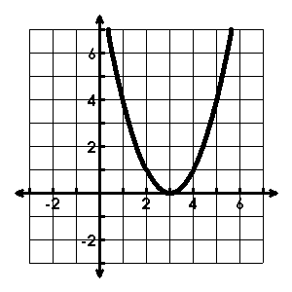11.

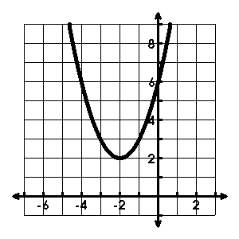12.

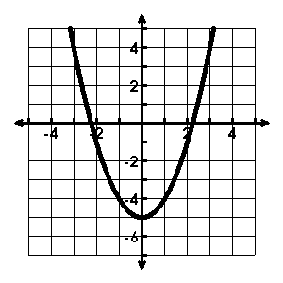13.

**14. Describe and correct the errors in analyzing the equation of f(x) = -6(x – 1)2 + 4.**

The graph is shifted up four units and shifted left one unit, followed by a stretch by a factor of 6, followed by a reflection over the x-axis. The vertex is (1, 4).

The graph is shifted up 1 unit and shifted right 4 units, followed by a stretch by a factor of 6, followed by a reflection over the x-axis of the graph of the parent quadratic function. The vertex is (-1, 4).

**15-20. Match each function to its graph.**

15. g(x) = 2(x – 1)2 – 2 16. g(x) = ½(x + 1)2 – 2 17. g(x) = -2(x – 1)2 + 2

18. g(x) = 2(x + 1)2 + 2 19. g(x) = -2(x + 1)2 – 2 20. g(x) = 2(x – 1)2 + 2

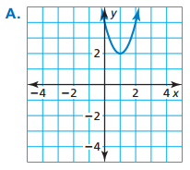 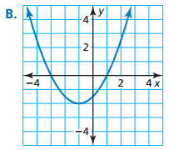 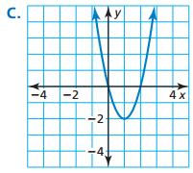

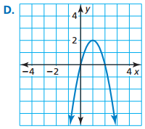 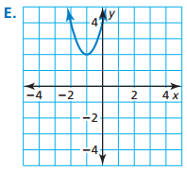 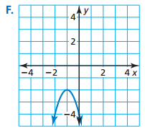

**Directions: Describe each transformation and name the vertex.**

|  |  |  |
| --- | --- | --- |
| **Graph** | **Vertex** | **Describe the transformation(s)** |
| y = x2 + 4 |  |  |
| y = x2 – 1 |  |  |
| y = 2x2 |  |  |
| y = -x2 + 6 |  |  |
| y = (x - 3)2 |  |  |
| y = -3(x + 2)2 |  |  |
| y = (x – 1)2 + 3 |  |  |
| y = 2(x + 6)2 |  |  |
| y = (x - 3)2 – 5 |  |  |
| y = -½(x + 4)2 + 5 |  |  |