**Day 6 – Graphing in Standard Form Name: ____________________________**

**Practice Assignment Date: _______________ Block: _______**

**Convert the following equations from vertex to standard form and find the y-intercept:**

a. y = (x – 2)2 – 8 b. y = (x + 7)2

**Find the vertex of the following:**

c. y = 3x2 – 18x + 17 d. y = – x2 + 8x -10

**Graph the following Quadratics:**



1. y = x2 + 6x + 6

|  |  |  |  |  |  |
| --- | --- | --- | --- | --- | --- |
| **x** |  |  |  |  |  |
| **y** |  |  |  |  |  |

2. y = 3x2 + 6x

|  |  |  |  |  |  |
| --- | --- | --- | --- | --- | --- |
| **x** |  |  |  |  |  |
| **y** |  |  |  |  |  |

**Match the graph of a quadratic to an equation (there may be more than one answer):**

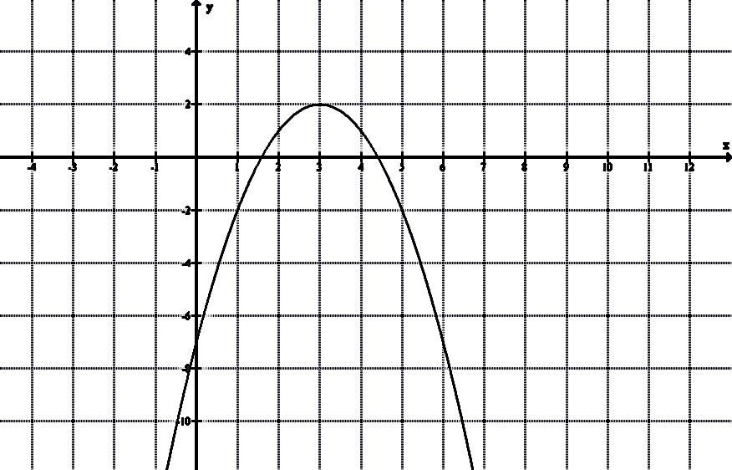

|  |
| --- |
| Equations: |
| 1. y = (x + 2)2 2. y = (x + 3)2 + 2 3. y = – x2 + 6x - 7 4. y = (x + 2)2 + 1 5. y = x2 + 4x + 4 6. y = – (x – 3)2 + 2 |

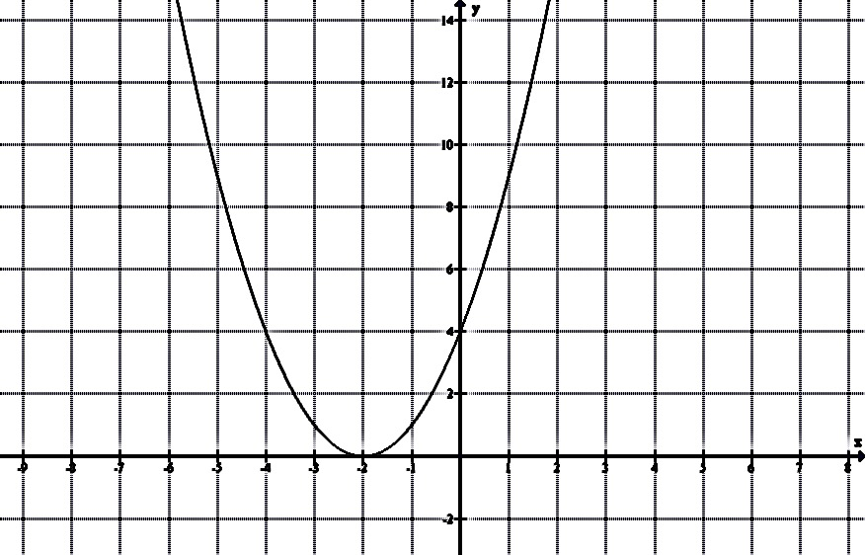

Answer (top graph)

_____________________

Answer (bottom graph)

_____________________