**HW - Function or Not? Name ________________________________**

Determine whether each relation is a function or not. Explain your answer.

|  |  |
| --- | --- |
| **Input** | **Output** |
| 4 | 7 |
| 6 | 8 |
| 8 | 11 |
| 12 | 15 |

1. (person, car) 2.

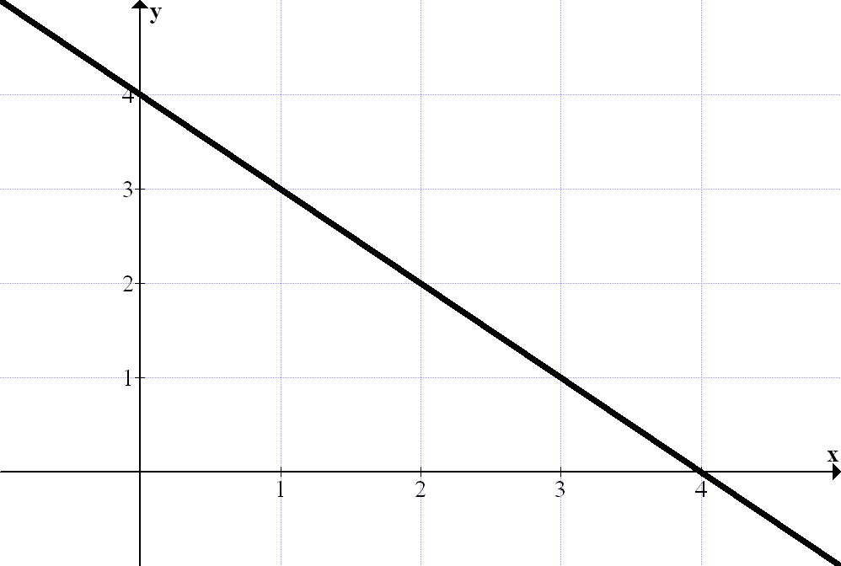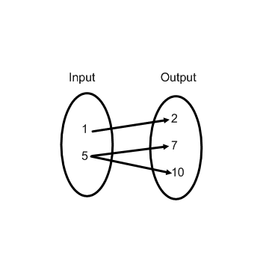

3. 4.

5.  6. (telephone number, person)

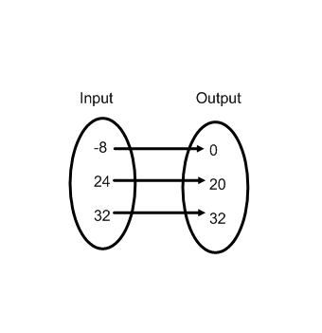

|  |  |
| --- | --- |
| **Input** | **Output** |
| -2 | 10 |
| 0 | 10 |
| 2 | 10 |
| 4 | 10 |

7. 8.

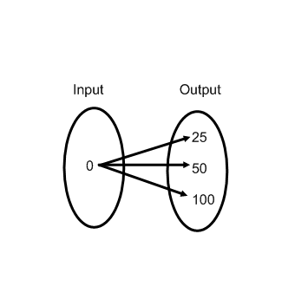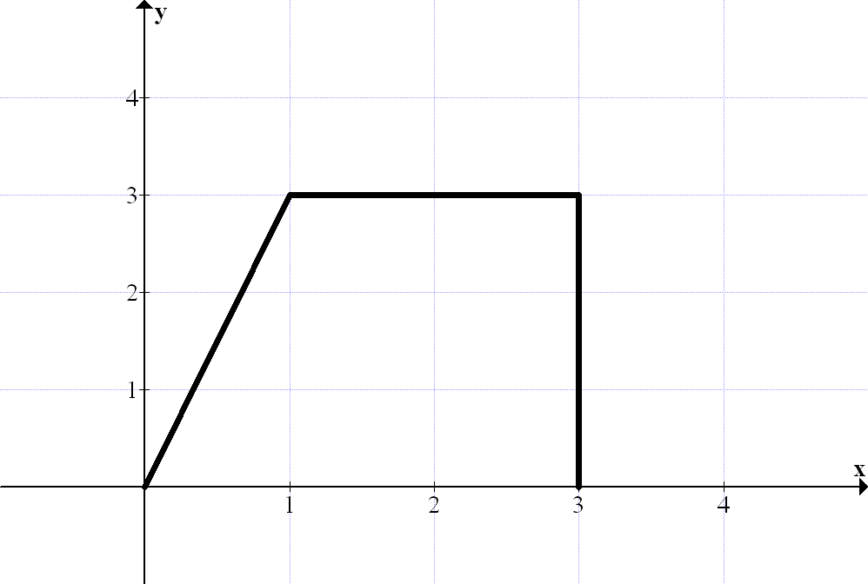9. 10.

|  |  |
| --- | --- |
| **Input** | **Output** |
| 12 | 10 |
| 12 | 5 |
| 12 | 0 |
| 12 | -5 |

|  |  |
| --- | --- |
| **Input** | **Output** |
| 5 | 18 |
| -4 | 14 |
| 0 | 3 |
| 5 | 18 |

11. 12.

**HW – Function Notation**

1. Let *f*(*t*) be the number of people, in millions, who own cell phones years after 1990. Explain the meaning of the following statements.

1. *f*(10) = 100.3 b. *f*(*a*) = 20
2. *f*(20) = *b d. n* = *f*(*t*)

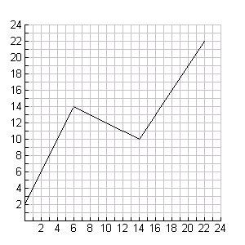

2. Use the graph of  below to answer each question.

a. Find the following values:

i.  ii. 

iii.  iv. 

b. What *x*-values make the following statements true?

i.  ii. 

iii.  iv. 

3. Could each set of ordered pairs below represent a function? Explain why.

1. (-2, 3), (3, -2), (1, 3), (0, -2) b. (3, -2), (-2, 3), (3, 1), (-2, 0)

4. Consider the function f(x) = 4x + 2.

1. What is f(-3)? b. What is f(2)? c. For what x-value is f(x) = 10?