EOC Review – Day 5 Name: _______________________________
Topic 10: Linear vs Exponential Patterns
Your Turn:
Linear Functions/Arithmetic Sequences:
- Add or subtract to get the next number
Exponential Functions/Geometric Sequences:
- Multiply or divide to get the next number

1a. Given the pattern 20, 25, … give the next number to make it a linear function. Explain why that would be the next number.

1b. Given the pattern 20, 25, …, give the next number to make it an exponential function. Explain why that would be the next number.

2a. Given the pattern 200, 210, … give the next number to make it an arithmetic sequence. Explain why that would be the next number.

2b. Given the pattern 200, 210, …, give the next number to make it a geometric sequence Explain why that would be the next number.

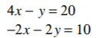
Topic 11: Solving Systems by Elimination Your Turn: Solve
- Use when your system of equations is in standard form
- Goal is to eliminate one of the variables using:
  - Addition
  - Multiply one or both equation by a number
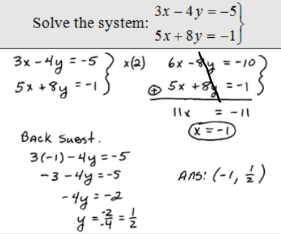

Your Turn:
