**EOC Review – Day 4 Name: _______________________________**

***Topic 7: Simplify Radicals – No Calculator!!***

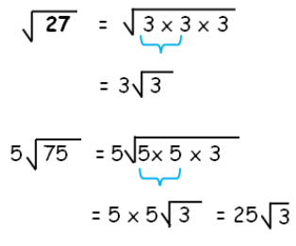 **Your Turn:** Simplify 

**Your Turn:** Simplify 

***Topic 8: Adding & Subtracting Radicals* Your Turn: **

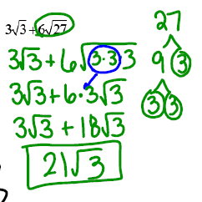

**Your Turn: **

On Back 🡪

***Topic 9 – Irrational vs Rational Numbers***

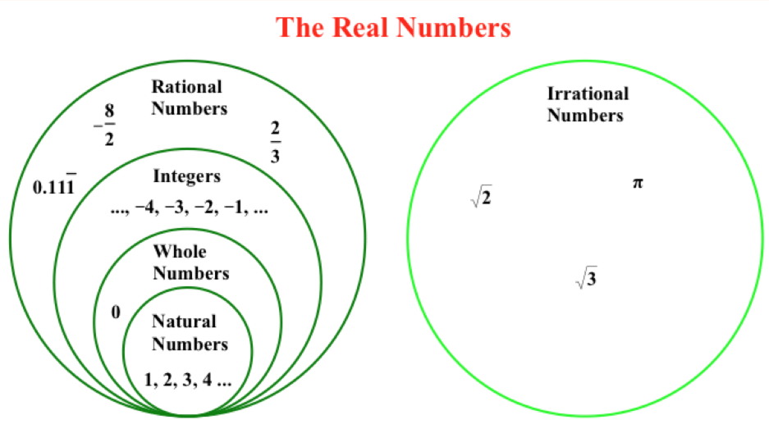

**Your Turn:** Classify the following numbers:

1.  2.  3.  4. 

5.  6.  7.  8. 