EOC Review – Day 3 Name: _______________________________
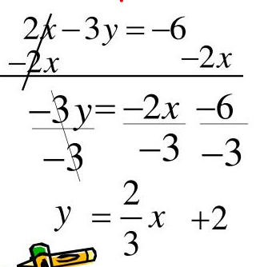
Topic 5: Solving for Y Your Turn: Solve 3x + 4y = 12

Your Turn: What is the slope and y-intercept of 2x – 5y = 15?

Topic 6: Factors vs Zeros Your Turn: What are the zeros of 2x² + 13x – 7 = 0?
Given: x² – x – 12 = 0
Factors: (x – 4)(x + 3)
Zeros: x = 4 and x = -3

Your Turn: What are the factors of x² – 49 = 0?
Given: 2x² – 7x + 3 = 0
Factors: (2x – 1)(x – 3)
Zeros: x = ½ and x = 3

Your Turn: What are the zeros of x² – 3x – 28 = 0?

