EOC Review – Day 2 Name: _________________________________
Topic 3: Solving Equations
Your Turn: Solve 5(4x – 2) + 9 = 2(8x + 7)
1. Distribute if possible
2. Combine like terms on each side
3. Move variables to one side and constants to the other side using inverse operations.
4. Isolate the variable.

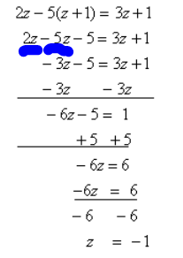

Your Turn: Solve 8x – 27 – 10 – 6x = 15

Topic 4: Solving Literal Equations
Remember….you can’t touch the variable you are solving for!
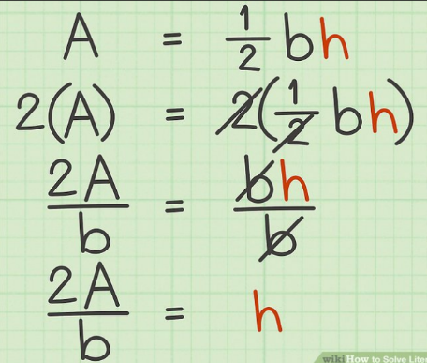
Your Turn: Solve for t: I = prt

Your Turn: Solve for w: P = 2w + 2l

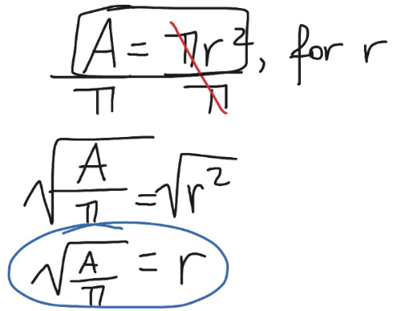

Your Turn: Solve for r: V = πr²h

