EOC Review – Day 1 Name: _______________________________
Topic 1: Solving Systems of Equations by Substitution
Worked Out Problem: Your Turn: y = 5x – 1
-3x + 2y = 12
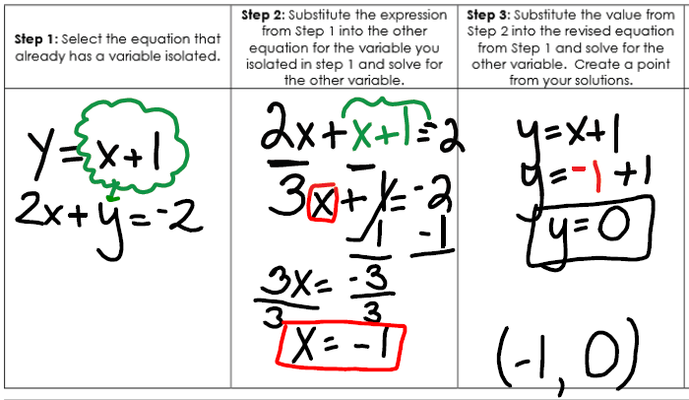

Topic 2: Finding the Vertex
Worked Out Problem Your Turn: Find the vertex of y = 2x² + 8x + 2.
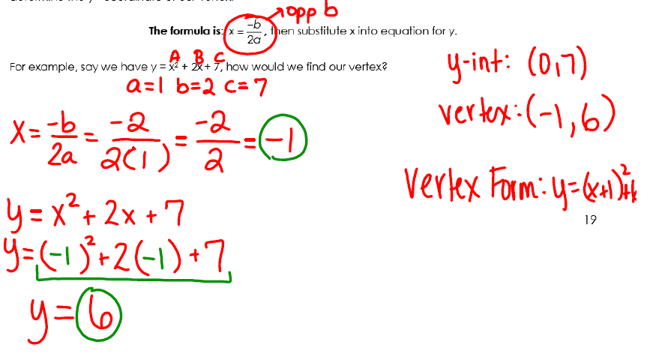

Your Turn Again: The height in feet of a rocket after x second is given by y = –16x² + 128x. What is the maximum height reached by the rocket and how long does it take to reach that height?

