**EOC Practice Test #4**

1.

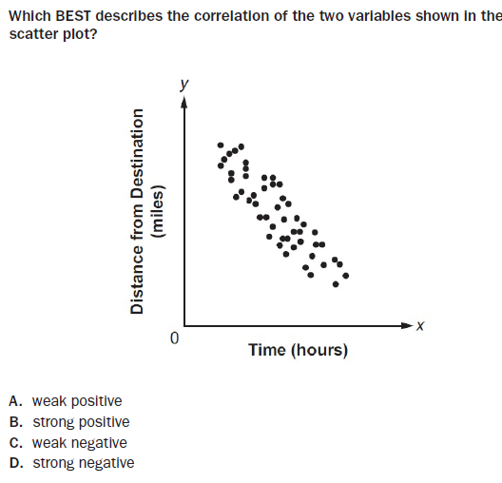

2.

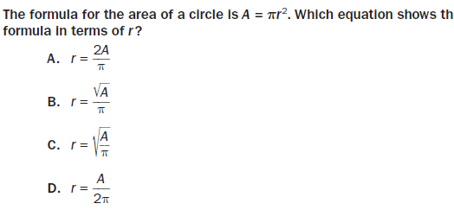

3.

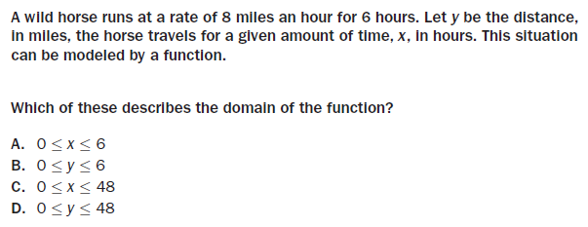

4.

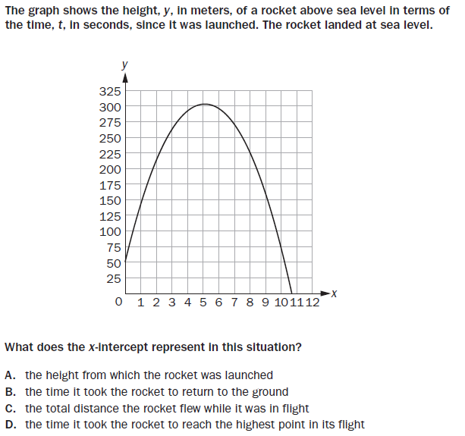

5.

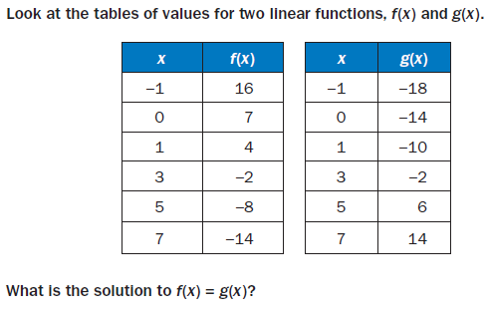

**A.** x = 1

**B.** x = 3

**C.** x = 5

**D.** x = 7

6.

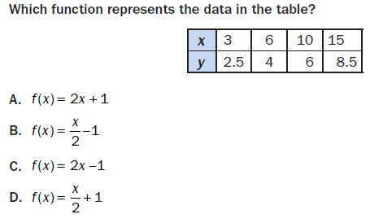

7.

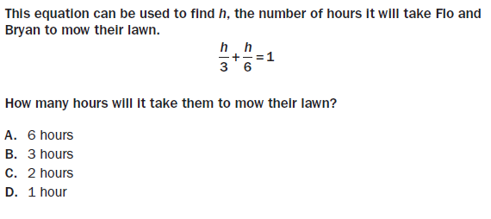

8. Consider the following function: f(x) = x2 + 5x – 14

**Part A:** What are the factors of the function?

**Part B:** What are the zeros of the function?

**Part C:** Explain the difference between factors and zeros of a function.

9.

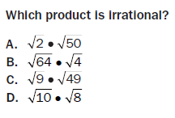

10.

