EOC Practice Test #3 – NO CALCULATOR!!!
1.
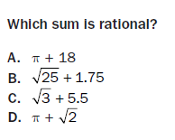

2.
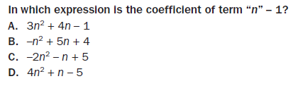

3.
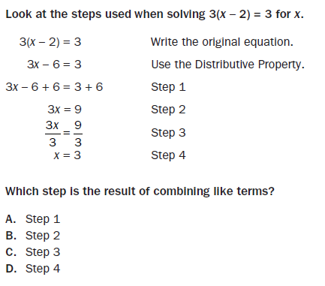

4.
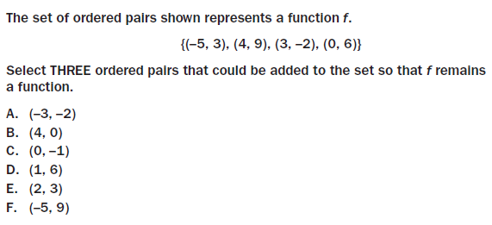

5.
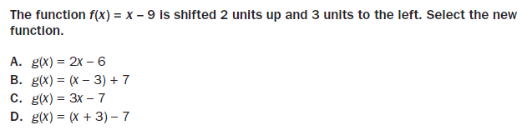

6.
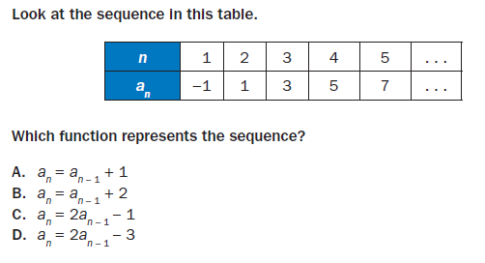

7. Consider the following set of data values that represent student grades on the EOC test.
88, 77, 92, 80, 93, 75, 81, 50, 85

Part A: Would the mean, median, or mode be the best measure to describe the data?

Part B: Explain why you chose the answer you did in Part A.

8.
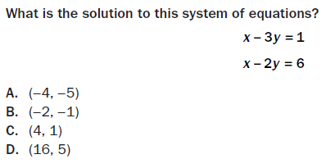

9.
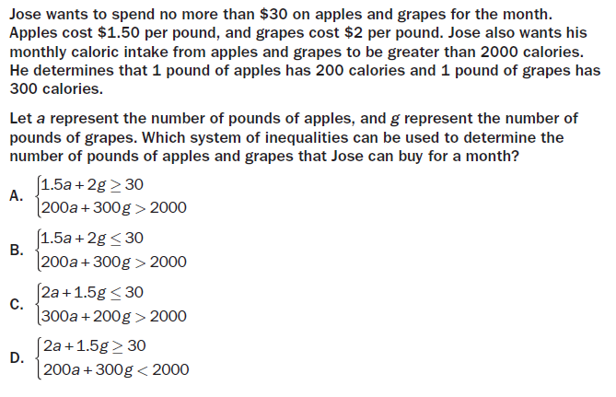

10.
