EOC Practice Test #1
1.
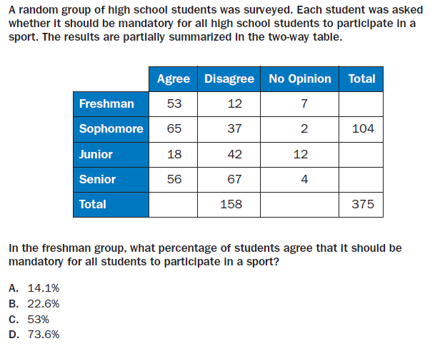

2.
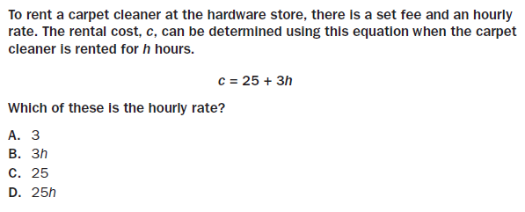

3.
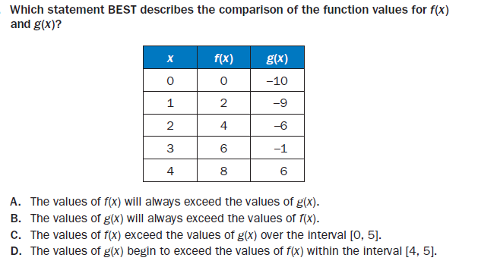

4.
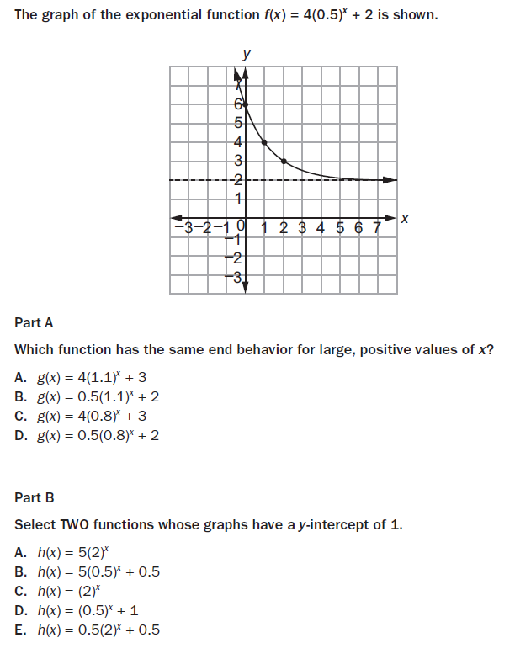

5.
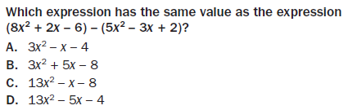

6.
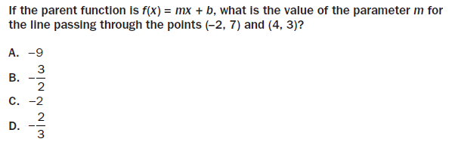

7.
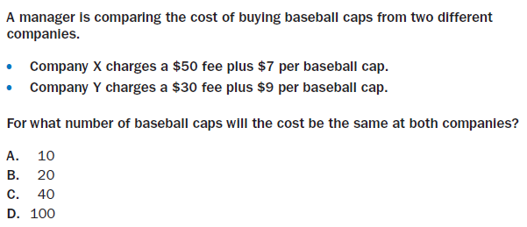

8.
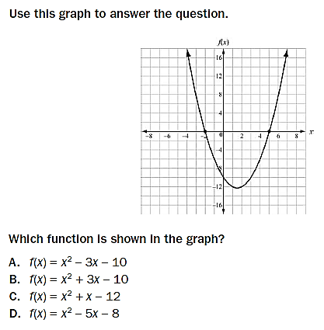

9.
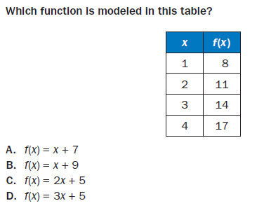

10. Consider the following table that displays how long a person works at a particular job and how much they get paid per hour.
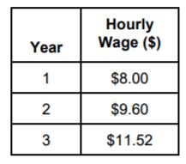
Part A: What type of sequence would this table represent?

Part B: Explain how you determined your answer in Part A.

Part C: Create an explicit rule that represents the sequence in the table.

Part D: How much money would a person make, per hour, after 7 years?

