**Operations with Polynomials Name: ____________________________**

**Practice Assignment Date: _______________ Block: _______**

**Multiply the following polynomials.**

1.  2.  3. 

4.  5.  6. 

7.  8. 

9. Write an expression for the perimeter and area of the following rectangle.

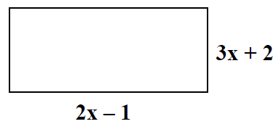

10. Write an expression for the area of the triangle. (A = ½ BH)

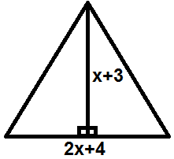

11. Find an expression for the volume of the pool below with the given dimensions.

X + 2

x + 4

x + 6