Day 8 – Writing Linear, Quadratic, & Exponential Equations Name: ____________________________
Practice Assignment

Directions: Identify the type of function. Then write an equation that represents each linear, quadratic, or exponential function. You must write all quadratic functions in standard form (y = ax² + bx + c).
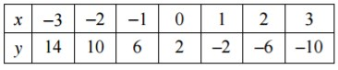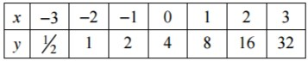

1. Type: ______________________________________ |  | 2. Type: ______________________________________
Equation: ____________________________________ |  | Equation: ____________________________________

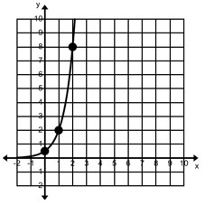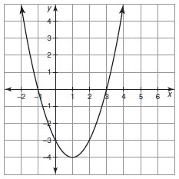
3. Type: ______________________________________ |  | 4. Type: ______________________________________
Equation: ____________________________________ |  | Equation: ____________________________________

x | 0 | 1 | 2 | 3 | 4
y | 27 | 9 | 3 | 1 | 1/3
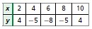
5. Type: ______________________________________ |  | 6. Type: ______________________________________
Equation: ____________________________________ |  | Equation: ____________________________________

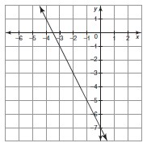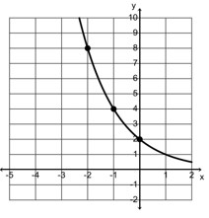

7. Type: ______________________________________ |  | 8. Type: ______________________________________
Equation: ____________________________________ |  | Equation: ____________________________________
9. Type: ______________________________________ |  | 10. Type: ______________________________________
Equation: ____________________________________ |  | Equation: ____________________________________
X | 1 | 2 | 3 | 4 | 5 | 6 | 7
Y | 8 | 3 | 0 | -1 | 0 | 3 | 8

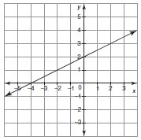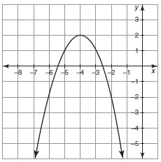

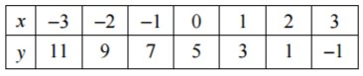

11. Type: ______________________________________ |  | 12. Type: ______________________________________
Equation: ____________________________________ |  | Equation: ____________________________________

