Day 8 – Comparing Linear, Quadratic, & Exponential Representations Name: ____________________________ Practice Assignment
Determine if each equation below represents a linear, quadratic or exponential function:

1. f(x) = 3x + 2 2. y = 3^{x} 3. y = 7² 4. f(x) = ½(2)^{x} + 1 5. y = x²

Determine if each graph represents a linear, quadratic or exponential function.

5. 6. 7.

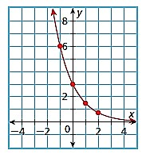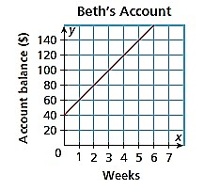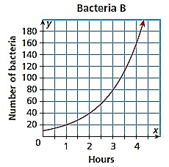

8. 9. 10.

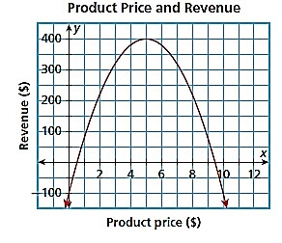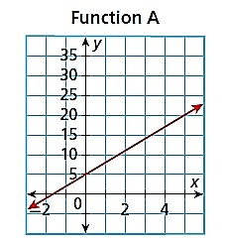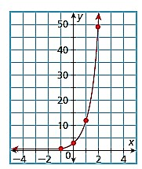

Determine if each sets of ordered pairs or tables represent a linear, quadratic or exponential function and justify why:
11. 12.
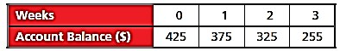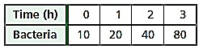

13. 14.
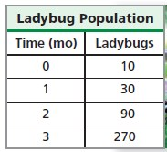
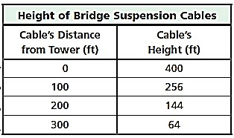

15. 16.
{(-4, 0), (-3, -5), (-2, -8), (-1, -9), (0, -8), (1, -5)}

