Day 7: Quadratic & Exponential Regression Name: ____________________________
Practice Assignment
1. Write a quadratic function, in standard form, that passes through the given points.
a. (-4, -1), (-2, 3), (-1, 8) b. (-2, 7), (-1, -6), (1, -20)

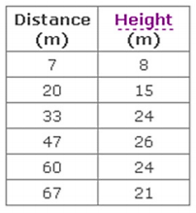
2. The following data table represents approximate heights for a ball thrown by a shot-putter as it travels x meters horizontally.
a. Find a quadratic model that represents the data.

b. What would be the height of a ball that travels 80 meters?

c. Is the ball in the air after 110 meters (according to your model)?

3. Gold’s closing price each year is shown in the table.
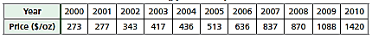

a. Find a quadratic model for the gold price over time using x = 0 for 2000. Does the model provide a good fit for the data? Explain using your scatterplot and table on your calculator.

b. What would be the price of gold in 2017 according to your model?

c. Using Google, what is the actual closing price for gold as of yesterday? Is your model accurate for 2017?

4. A colony of bacteria grows exponentially. The table below shows the data collected daily.
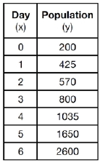
a. Write an exponential regression equation for the data, rounding all values to the hundredths place.

b. Explain what the “a” and “b” values represent in terms of the problem context.

c. What is the growth rate?

d. How many bacteria will be present on Day 10?

5. A cup of soup is left on a countertop to cool. The table below gives the temperatures, in degrees Fahrenheit, of the soup recorded over a 10-minute period.
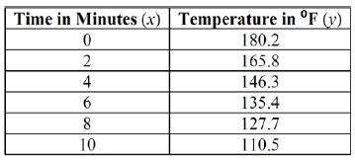
a. Write an exponential regression equation for the data, rounding all values to the hundredths place.

b. Describe what the “a” and “b” values represents in terms of the problem context.

c. What is the decay rate?

d. If this trend continues, when will the soup reach 100 degrees Fahrenheit?

Day 7: Quadratic & Exponential Regression Name: ____________________________
Practice Assignment 6. The table below gives the average annual cost (e.q. tuition, room, and board) for four year public universities. Let 1981 be t = 0.

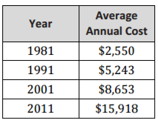
a. Write an exponential regression equation for the data, rounding all values to the hundredths place.

b. Describe what the “a” and “b” values represents in terms of the problem context.

c. What is the growth rate?

d. If this trend continues, when will the average cost of attendance exceed $35,000?

7. The table below shows the amount of a decaying radioactive substance (in grams) that remained for selected years after 1990.
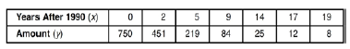
a. Write an exponential regression equation for the data, rounding all values to the hundredths place.

b. Describe what the “a” and “b” values represents in terms of the problem context.

c. What is the decay rate?

d. Using your equation, how much substance remained in 2002?

