Day 6: Linear Regression Name: ____________________________
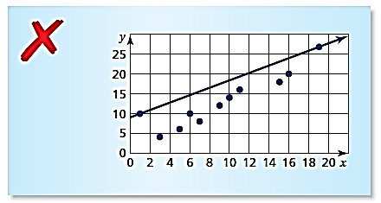
Practice Assignment
1. Describe and correct the error found in the example
to the right about drawing a line of best fit.

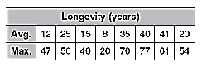
2. The table shows the average and maximum longevity of various animals in captivity.

a. Draw a scatterplot and determine, what relationship, if any,
exists in the data.
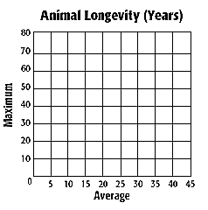

b. Draw a line of best fit and find the equation of the line.

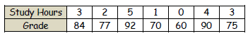
3. The table at the right gives the number of hours spent studying for a science exam and the final grade.
a. Draw a scatterplot and draw in the line of best fit.

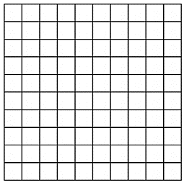
b. What is the equation for the line of best fit? What is the correlation coefficient? What does it tell you about your linear model?

c. Predict the grade of a student who studied for 6 hours.

d. What does the slope and y-intercept mean in context of the problem?

4. These are the asking prices for some used Toyota Corolla’s in newspaper classifieds in 2006 (t = 0).
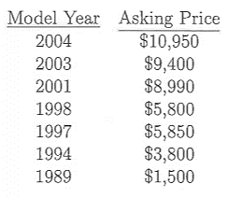
a. Using your calculator, calculate a model to represent the data to the left (Round numbers to the nearest whole number).

b. What is the slope of the line you found in Part A? What does that number represent in context of the problem?

c. What is the y-intercept of the line in Part A? What does that number represent in context of the problem?

d. What is the correlation coefficient? What does this tell you about the linear model you found?

6. Use the graph to below to determine the linear regression and correlation coefficient.
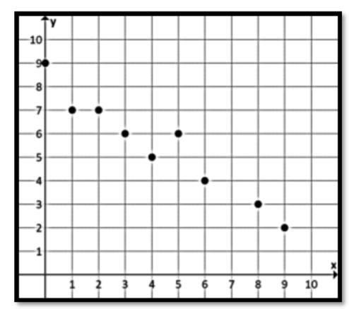

7. Use the graph to below to determine the linear regression and correlation coefficient.
