**Day 6 Practice Name: ________________________**

**Algebraic Relationships with Parallel Lines**

**Name the relationship you would use to solve for variable(s). Then solve for each variable.**

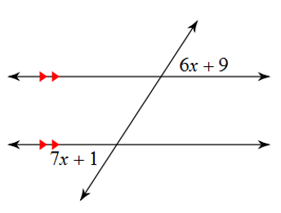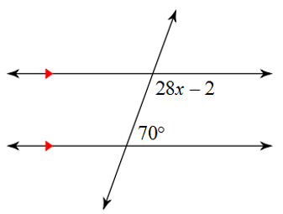1. _________________________________ 2. _________________________________

3. _________________________________ 4. ________________________________



5. _________________________________ 6. _________________________________



7. _________________________________ 8. _________________________________



9. _________________________________ 10. _________________________________

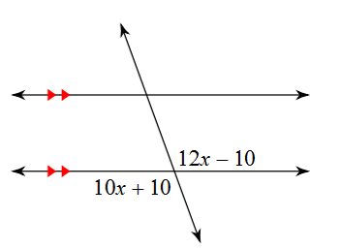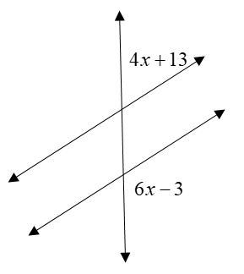



11. _________________________________ 12. _________________________________

