**Day 4 Practice Name: _________________________________**

**Angle and Segment Relationships**

Find the measure of the stated angle.

1. 2.

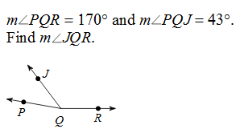 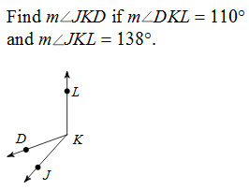

3. 4.

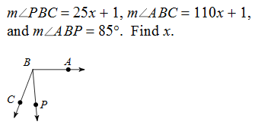 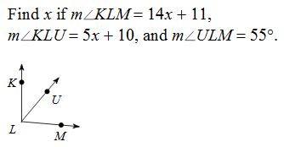

Given that bisects , find the measure of the other two angles (whole angle and missing angle).

5. 6. 7.

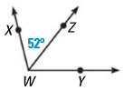 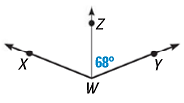 q 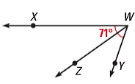

Given that bisects , find the measure of .

8. 9.

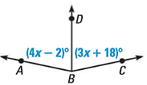 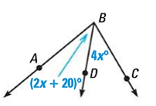

Find the measure of the stated segment.

10. 11. 12.

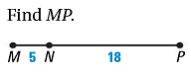 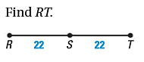 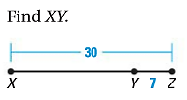

13. 14. 15.

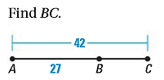 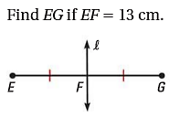 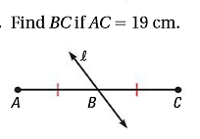

16. If RS = TU, ST = 9, RU = 33

a) Find RS b) Find SU.

17. In the diagram, points V, W, X, Y, and Z are collinear. VZ = 52, XZ= 20, and WX = XY = YZ. Find the indicated lengths. 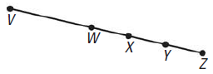

a. WX d. VW

b. VW e. WZ

c. WY f. VY

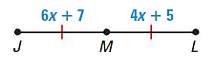18. M is the midpoint of JL. Find JM. 19. Line is the segment bisector of . Find the

length of PQ.

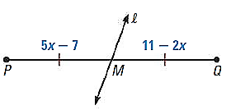

20. 21.

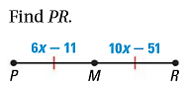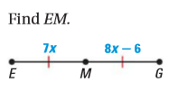

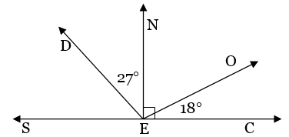22. Find the measure of each angle. **REVIEW**

a. m∠NEO = _______ b. m∠DES = _______

c. m∠DEO = _______ d. m∠SEO = _______

23. Find the values of x and y. **REVIEW**

a. b.

