Day 4: Scatterplots Name: ____________________________
Practice Assignment

1. Determine if the following scatterplots show a positive, negative, or no correlation.
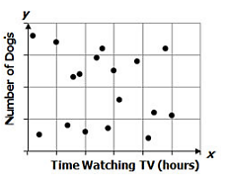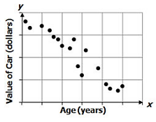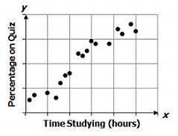

2. Fawn is trying to improve her reading skills by taking a speed reading class. She is measuring how many words per minute (wpm) she can read after each week of the class.
b. Describe the correlation illustrated by the plot. Then calculate the correlation coefficient.
a. Create a scatterplot for the data below:
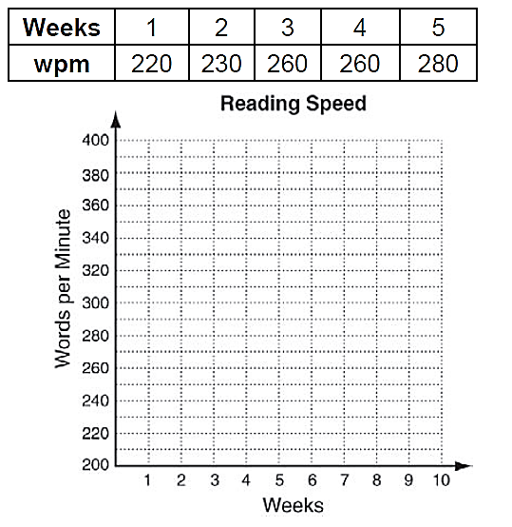

c. Draw a trend line and use it to predict the number of words per minute Fawn will read after 8 weeks of this class.

d. Fawn is paying for the classes out of pocket. Identify the type of correlation between number of classes and her bank account balance.

3. Choose the scatterplot that best represents the relationship between the number of minutes since a pie has been taken out of the oven and the temperature of the pie. Explain why each graph fits or does not fit the above scenario.
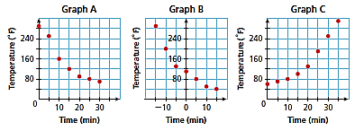
Graph A:

Graph B:

Graph C:
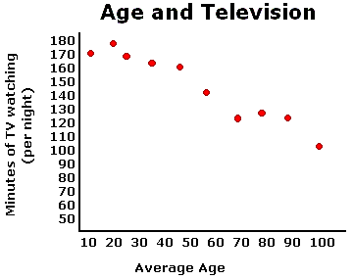
4. What can be concluded from the scatterplot below?
A. The older a person gets, the more television they watch.

B. As a person gets older, their taste in television changes.

C. The older a person gets, the less television they watch.

D. There is no relationship between age and television watching.

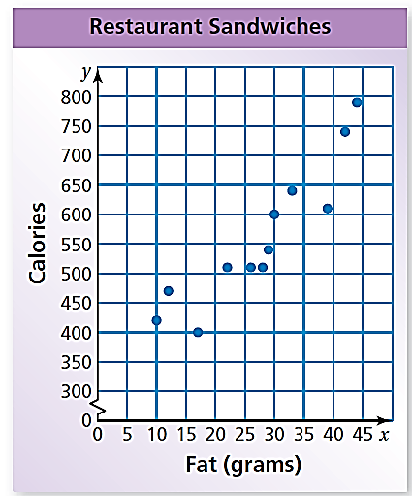

5. The scatterplot shows the number of fat (grams) in a restaurant
sandwich and the number of calories.

a. How many grams of fat would you predict to be in a sandwich
that contains 650 calories?

b. How many calories would you predict to be in a sandwich with
20 grams of fat?

6. Make a scatterplot for each data set. Then find the correlation coefficient using your calculator.
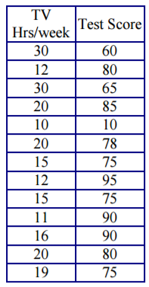
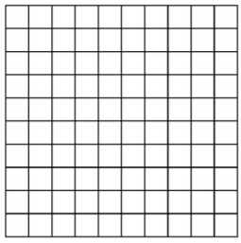
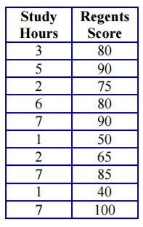
a. b.

7. Match the graph with its correlation coefficient.
Choices
A. r = 0.45
B. r = 0.94
C. r = 0.07
D. r = -0.39
E. r = -0.89
