Day 4: Comparing Data Displays Name:____________________________
Practice Assignment Block: _______
1. Josh and Richard each earn tips at their part-time job. This table shows their earnings from tips for five days.

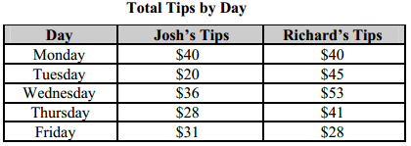

a. Who had the greatest median earnings from tips?

b. What is the difference in the median of Josh’s earnings from tips and the median of Richard’s earnings from tips?

c. What is the difference in the interquartile range for Josh’s earnings from tips and Richard’s earnings from tips?

2. Forty-five people were asked about how many miles they walked in one week. The results are shown in the graph.
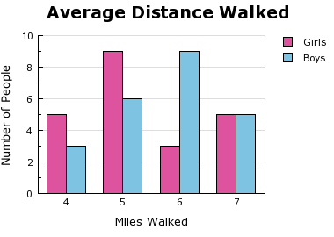
a. What is the mean number of miles walked for girls?

b. What is the mean number of miles walked for boys?

c. Compare the means.

3. A science teacher recorded the pulse rates for each of the students in her classes after the students had climbed a set of stairs. She displayed the results, by class, using the box plots shown.
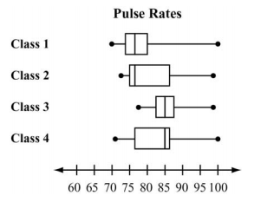
a. Which class had the biggest interquartile range?

b. Which class has the least amount of spread or variability in their data?

c. Which class had the least spread between Q₂ and Q₃?

d. Which class generally had the highest pulse rates after climbing the stairs?

4. | Noah conducted a survey on sports participation. He created the following two dot plots to represent the number of students participating, by age, in soccer and basketball. Which statement about the given data sets is correct? |  | 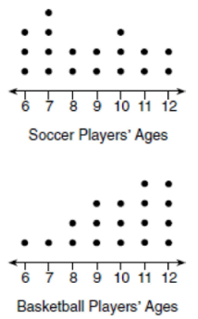
 | (A) | The data for the soccer players is skewed right.
 | (B) | The data for the soccer players have less spread than the data for the basketball players.
 | (C) | The data for basketball players have the same median as the data for soccer players.
 | (D) | The data for basketball players have a greater mean than the data for soccer players.

5. | Corinne is planning a beach vacation in July and is analyzing the daily high temperature for her potential destination. She would like to choose a destination with a high median temperature and where the temperature does not fluctuate very much. Which destination should she pick and why? |  | 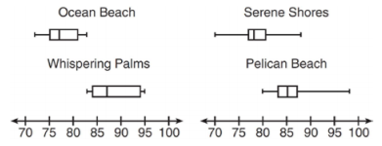
 | (A) | Ocean Beach
 | (B) | Whispering Palms
 | (C) | Serene Shores
 | (D) | Pelican Beach

Explanation:

