**Day 4: Average Rate of Change Name: ____________________________**

**Practice Assignment**

**Directions:** Find the average rate of change for the given intervals

1. 0 ≤ x ≤ 3 2. -1 ≤ x ≤ 2

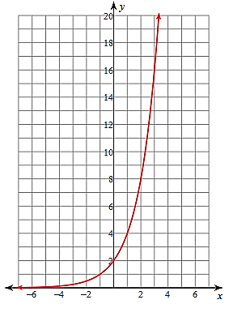 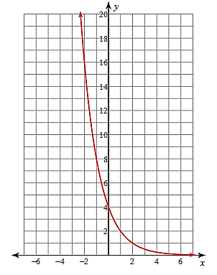

3. -1 ≤ x ≤ 1 4. 0 ≤ x ≤ 1

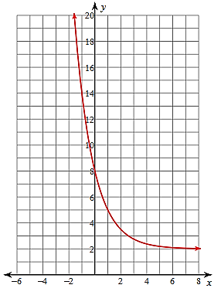 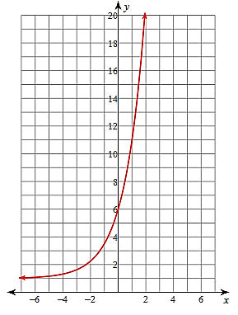

5. A type of bacteria doubles every 36 hours. A petri dish starts out with 12 of these bacteria. Use the table below to calculate the rate of change for the interval [2, 5].

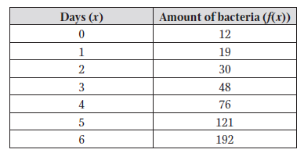

6. Find the average rate of change for the following functions on the given interval.

a. , 2 ≤ x ≤ 5 b. , 1 ≤ x ≤ 3

7. Use the table below to answer the following questions:



a. Create three y-values that complete the table so the function would be linear.

b. Create three y-values that complete the table so the function would be exponential.

c. Create your own table of values for a function that is linear and has constant first differences of -3.

d. Create your own table of values for a function that is exponential and has constant ratio of 3.