**Day 4 – Applications of Polynomials Name: ____________________________**

**Practice Assignment Date: _______________ Block: _______**

1. Find the perimeter of the following figures:

a. b.

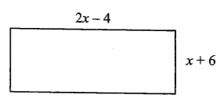 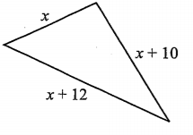

2. The measure of the perimeter of a triangle is 37x + 42. It is known that two of the sides of the triangle have measures of 14x + 16 and 10x + 20. Find the length of the third side.

3. A rectangle has a perimeter of 12y2 – 2y + 18 and has a width of 4y2 – y + 6. What is the length of the rectangle?

4. Write an expression for the perimeter and area of the following rectangle.

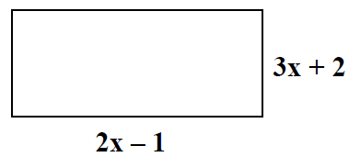

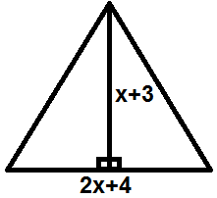5. Write an expression for the area of the triangle ().

6. Find the area of the shaded region:

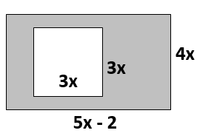

7. Find the area of the shaded region:

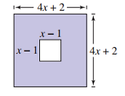

8. The polynomial  models the cost a company incurs from making an item at a price *x*. The polynomial  represents the income from selling the same item at a price x. Write a polynomial that expresses the profit from making and selling the item. (hint: profit = income – cost)