**Day 3 Practice Name_________________________**

**Vertical Angles & Linear Pairs**

**Examples**:

1) Find x, y, and z

x

51° Y

z

4

5

6

2) Given: m∠4 = (2x + 5)°

m∠5 = (x +30)°

Find: m∠6

3) Identify each pair of angles as adjacent, vertical, complementary, supplementary, and/or linear pair.

1

2

3

4

5

1. ∠1 and ∠2

1. ∠3 and ∠4
2. ∠5 and ∠4

d) ∠3 and ∠5



4) Find x and y if ∠CBD is congruent to ∠FDG.



5) Find each of the following:

1. x
2. m∠LAT
3. m∠TAO

d) m∠PAO



**In the figure, *GA* and *GD*, and *GB* and *GE* are opposite rays.**

6) Which angle forms a linear pair with ? ________

7) Do  and  form a linear pair? ________

8) Name two angles that are adjacent to . ________ ________

9) Name two angles that form a linear pair with . ________ ________

10) Name three angles adjacent to . ________ ________ ________

11) Do  and  form a linear pair? ________

12) Name the vertical angle to. _______________

13) Name another pair of vertical angles. ____________ and _______________

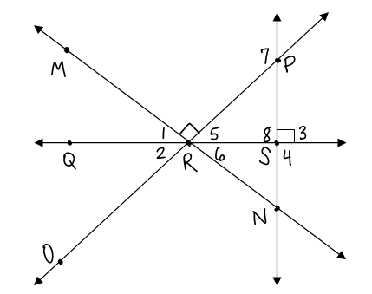

14) *True or False?*

a. ∠PRN is acute.

b. ∠4∠8

c. m∠5 + m∠6 = 90

d. 

e. ∠7 is obtuse