Day 3: Comparing Sequences Name: ____________________________

Practice Assignment Block: ______________

1. Edgar is getting better at math. On his first quiz he scored 57 points, then he scored 61 and 65 on his next two quizzes.

  - Write an explicit formula for the sequence. Explain where you found the numbers you are putting in the formula.

b. If his scores continued to increase at the same rate, what will be his score on his 9th quiz?

2. The yearbook staff is unpacking a box of school yearbooks. The sequence 281, 270, 259, 248,… represents the total number of ounces that the box weighs as each yearbook is taken out.
a. What is the weight of each yearbook?

b. Create an explicit rule for the sequence.

c. After 20 yearbooks were unpacked, how much did the box weigh?

d. If the full box of yearbooks weighs 292 ounces, how many yearbooks were in the box?

3. A ball is dropped from a height of 500 meters. The table shows the height of each bounce, and the heights form a geometric sequence.
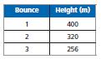
a. Create an explicit rule for the sequence.

b. How high does the ball bounce on its 8th bounce? Round your answer to the nearest tenth.

4. Camden is collecting bugs for science class. The first day his sister helps him, and he finds 35 bugs. After day 2, he has 52 bugs. On day 3, he has 69 bugs. How many bugs will he have on the 15th day?

5. After the first day at work, Annie realized that she sent 127 e-mails. Each day, Annie’s e-mail count increased by 10. If she keeps this up, how many e-mails will she have sent after 3 weeks?

Explicit Rule: ____________________________ After 3 weeks: ___________________

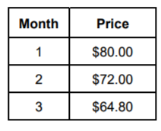
6. A shoe store is discounting shoes each month. A pair of shoes costs $80. The table shows the discount prices for several months. Find the cost of the shoes after 8 months.

Explicit Rule: ____________________________ After 8 months: ___________________

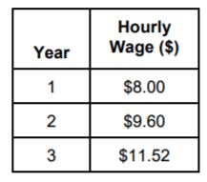
7. Breno got a job at a starting salary of $8.00 per hour. His boss told him that if he works hard, he can get a raise each year. The table shows Breno’s wages for the first years. Find Breno’s hour wage after 6 years.

Explicit Rule: ____________________________ After 6 years: ___________________

