**Day 3: Box Plots Name:____________________________**

**Practice Assignment Block: _______**

1. The accompanying box-and-whisker plot represents the cost, in dollars, of twelve CD’s.



1. Which cost is the upper quartile?
2. What is the range of the costs of the CD’s?
3. What is the median?
4. Which cost represents the 100th percentile?
5. How many CD’s cost between $14.50 and $26.00?
6. How many CD’s cost less than $14.50?

2. The box and whisker plot below shows the starting salaries for 120 graduates of a small college.  
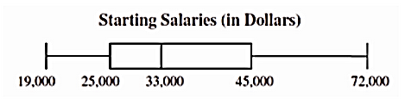  
 a) What is the range of the starting salaries?  
  
 b) About 30 graduates make below what amount?  
  
 c) How many graduates have a salary above $33,000?  
  
 d) 25% of the graduates make above what amount?

3. Mr. Andrews made a box-and-whisker graph of the quiz grades in his chemistry class.  
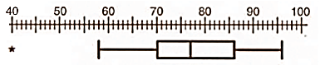  
 a) What grade is the lower quartile?  
  
 b) What is the interquartile range?  
  
 c) Which grade represents the 75th percentile?  
  
 d) What is the highest grade scored on the quiz?

e) Are there any outliers? Explain what this means in context of the problem.

4. The accompanying box-and-whisker plots can be used to compare the annual incomes of three professions. Based on the box-and-whisker plots, determine if each statement is true or false. If false, correct the statement.

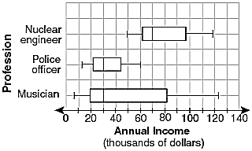a. The median income for nuclear engineers is greater than the income of all musicians.

b. The median income for police officers and musicians is the same.

c. Nuclear engineers have the largest interquartile range of incomes among the three professions.

d. All nuclear engineers earn more than all police officers.

e. Police officers have the less variability (difference in spread) in earnings.

f. 25% of musicians make$20,000 or less.

g. There are more data values for musicians between the median and Q3 than between Q1 and the median.

h. 50% of musicians make between $20,000 and $81,000.

i. 50% of nuclear engineers make between $50,000 and $70,000.

j. Nuclear engineers have the largest range of incomes.

**TV & Homework Minutes per Night**

The box plot represents 160 freshmen and how much time they spend on homework and watching TV.

**Homework Time**

0 20 48 60 190

**TV Time**

0 15 60 110 225

________ 1. What percent of the freshmen watch TV for at least 15 minutes per night?

________ 2. What is the 3rd quartile for the TV time data?

________ 3. How many freshmen spend 60 minutes or less working on homework?

________ 4. How many freshmen spend at least 110 minutes watching TV?

________ 5. What percent of freshmen completed between 20 and 60 minutes of homework?

________ 6. What percent of freshmen watched 60 to 225 minutes of TV a night?

________ 7. Are there any outliers?

For questions 8 – 13, identify if each statement is true, false, or cannot be determined.

________ 8. Some freshmen didn’t watch TV that month.

________ 9. 15% of freshmen did not watch any TV.

________ 10. 25% of the freshmen spend between 48 & 60 minutes per night on homework.

________ 11. 75% of the freshmen spend at least 60 minutes watching TV.

________ 12. In general, these freshmen spend more time watching TV than doing homework.

________ 13. The homework box plot is skewed left.

14. Is it more common for a freshman at this high school to spend more than 1 hour on homework or more than 1 hour watching TV? Explain.

15. How would you describe both distributions? Explain why.