Day 2: Dot Plots and Histograms Name:____________________________
Practice Assignment Block: _______
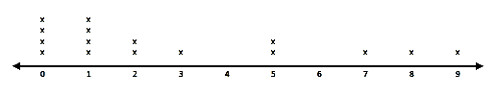
1. Analyze the given dot plot which displays the number of home runs by each member of the Atlanta Braves team this season so far and answer the questions accordingly.

a. Describe the distribution of the data. Is the data skewed left or right? What does this mean in terms of the problem?
b. How many players are on the team? c. How many players hit more than 2 home runs?
d. How many players hit at least 1 home run? e. How many players scored more than 1 and fewer than 9
home runs?

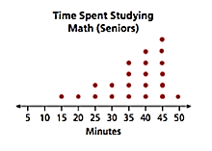
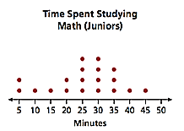
2. Find the mean, median, mode, and range of each dot plot. Then, answer the questions.
Mean: ________________ Mean: ________________
Median: ________________ Median: ________________
Mode: ________________ Mode: ________________
Range: ________________ Range: ________________
a. Which dot plot has the greater mean? Why?
b. Is the mean or the median the better measure of central tendency of the data for Juniors? Why?
c. Is the mean or the median the better measure of central tendency of the data for Seniors? Why?

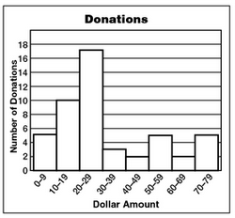
3. The histogram shows the amount of money in dollars that people donated to a fund to help save the whales.
a. How many people donated between $50 and $59?
b. For which interval did the most people donate money to the fund?
c. How many people donated $50 or more to the fund?
d. Is the data skewed left, skewed right, or symmetric? Explain what this means in context of the problem.

e. At about what value would the median fall?

4. Match each histogram to the appropriate description. Then explain why you chose each scenario for each histogram.
_______ i. The first 5000 digits of pi (hint: each digit is used approximately the same number of times)
_______ ii. SAT scores for a group of college students.
_______ iii. The number of medals won in the 1992 Winter Olympics.
_______ iv. The scores on a fairly easy US History test.
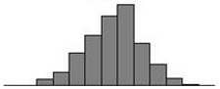
a. b.

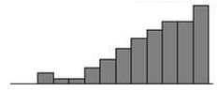
c. d.

