**Day 1 Practice Name: ___________________________**

1. Name each angle in 3 ways:

a. b. c.

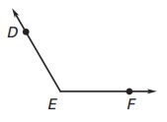 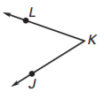 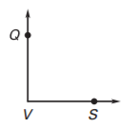

2. Classify the angles as obtuse, acute, right, or straight.

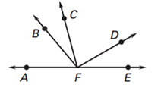a. DFE

b. CFE

c. AFB

d. AFE

3. Classify the angles as obtuse, acute, right, or straight.

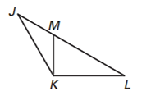a. LKJ

b. JLK

c. KJL

d. MKL

e. JML

f. KMJ

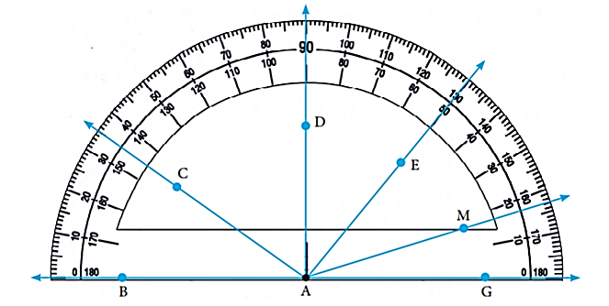4. Use the diagram to name an angle with the following angle measures.

a. 90°

b. 145°

c. 50°

d. 163°

e. 17°

f. 130°

g. 55°

h. 33°

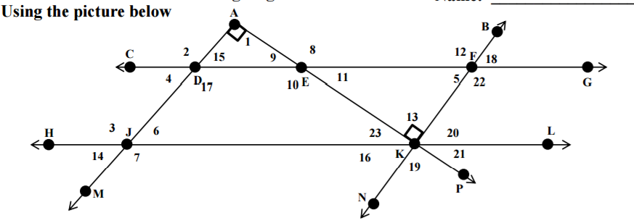

Answer the following:

a. Name 12 in two other ways. __________ & __________

b. Name AEF in two other ways. __________ & __________

c. Name 9 in two other ways. __________ & __________

d. Name DJK in two other ways. __________ & __________

e. Which angle(s) are right angles? __________ & __________ & __________

f. Which angle can only be named using 1 letter? __________

g. Name in three other ways. __________ & __________ & __________

h. Name in as many ways as possible. _____________________________

i. Name in two other ways. __________ & __________

g. Name in three other ways. __________ & __________ & __________

h. Name in as many ways as possible. ______________________________

i. Name in two other ways. __________ & __________

j. intersects lines __________ & __________

k. intersects lines __________ & __________ & __________

l. 

m. 

**Practice Measures Angles with a Protractor**

1. Use the diagram shown to determine the measure of each angle. Then classify each angle.

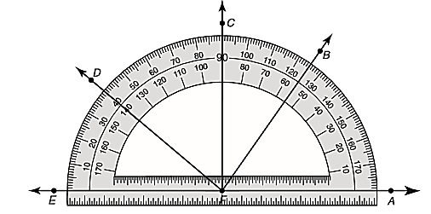

a. AFD b. AFB c. EFD d. EFB

e. DFB f. CFA g. EFA h. BFC

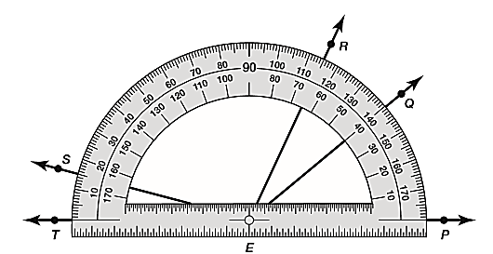

a. SET b. QEP c. REQ d. REP

e. TEQ f. PES g. SER h. TEP