Day 1: Measures of Central Tendency & Spread Name:____________________________
Practice Assignment Block: _______
1. Find the following for the set of data below:

Unit 10 Test Scores: 32, 54, 87, 84, 95, 72, 91, 75, 80, 72

1.) Find the mean  (Round to nearest whole number) | 2.) Find the median(Q2). | 3.) Find the mode.
4.) Find the range. | 5.) Find Q1. | 6.) Find Q3.
7.) Find the IQR. | 8.) Find the MAD.

b. Which number appears to be an outlier and why?

c. What does the outlier do to the mean? If the outlier were removed, what would happen to the mean?

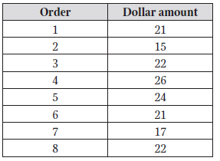
2. A website captures information about each customer’s order. The total dollar amounts of the last 8 orders are listed below.

a. What is the mean absolute deviation?

b. What does the mean absolute deviation mean in context of the problem scenario?

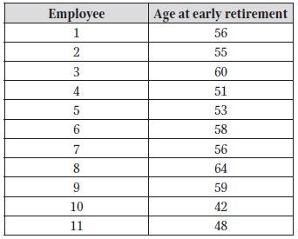
3. A company keeps track of the age at which employees retire. It is considered an early retirement if the employee retires before turning 65. The age of 11 employees who took early retirement this year are listed in the table.

a. Find the values of Q1, Q2, and Q3.

b. Find the interquartile range.

c. Are there any striking deviations in the data?

4. Your scores on the first 4 tests in Algebra were 85, 80, 90, and 93. What do you need to make on the 5th test to have a 90 average in the class?

