**Day 1: Sequences Name: ____________________________**

**Practice Assignment Block: ______________**

**For the following sequences, identify the type, create the explicit formula. Then find the stated nth term.**

1. -10, -4, 2, 8, 14, … Formula:Find a26 =

1. 4, 5, 6.25, … Formula: Find a9
2. 3, 6, 12, … Formula:Find a10

1. 12, 8, 4, 0…. Formula:Find a31 =
2. 6, 11, 17, … Formula Find a42 =

1. 5, -25, 125, … Formula: Find a8 =
2. 36, 31, 26, 21, … Formula:Find a17 =

**For the given information, generate the first five terms:**

8. an = 3(2)n-1 9.  10. an = 5(-2)n-1

11.  12. an = 12(1/4)n-1 13. 

**For the given information, use it to create an explicit rule.**

14. Geometric: a4 = 16, r = 2 15. Geometric: a5 = -64, r = 4 16. Arithmetic: a8 = 36, d = 2

17. Count the number of lines creating each figure and answer the questions below:

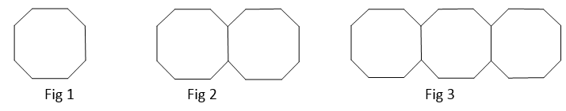

Complete the table below:

|  |  |  |  |  |  |
| --- | --- | --- | --- | --- | --- |
| Fig # | 1 | 2 | 3 | 4 | 5 |
| # of lines |  |  |  |  |  |

1. Write the **EXPLICIT** rule for the number of lines needed to generate each shape.
2. How many lines would be used to create figure #20?