**Day 1: Evaluating Exponential Functions Name: ____________________________**

**Practice Assignment**

Evaluate each exponential function for the stated value.

1. f(x) = ; x = 2 2. f(n) = ; f(-2) 3. y = ; x = 4

**Answer the following word problems:**

4. If a basketball is bounced from a height of 20 feet, the function f(x) =20(0.9)x gives the height of the ball in feet of each bounce, where x is the bounce number. What will be the height of the 6th bounce? Round your answer to the nearest tenth of a foot.

5. Suppose the depth of a lake can be described by the function y = 334(0.976)x, where *x* represents the number of weeks from today. Today, the depth of the lake is 334 ft. What will be the depth in 6 weeks? Round your answer to the nearest whole number.

**Name the asymptote for each graph:**

6. 7. 8.

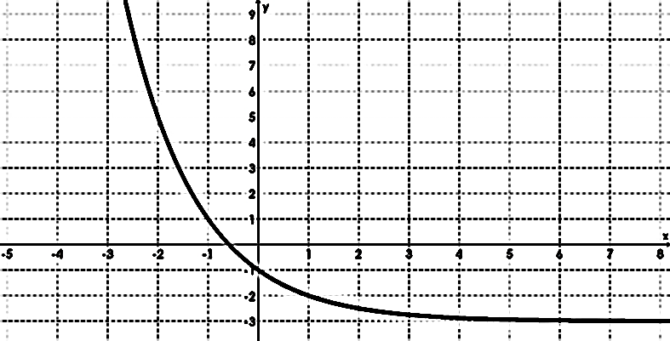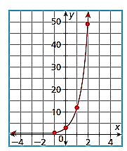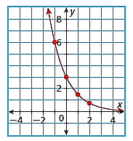

**Directions:** Decide whether each of the following is an example of exponential growth (increase) or decay (decrease) and explain why. Then state the y-intercept.

9. y = 5x 10.  11. y = -3x 12. y = 2

Directions: Create an equation to represent each table or graph.

13. 14. 15.

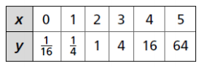 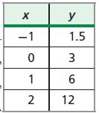 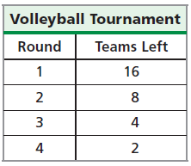

16. 17. 21.

