Day 11: Comparing Multiple Representations of Functions Name: ____________________________
Practice Assignment Block: _______

1. Your employer has offered two pay scales for you to choose from. The first option is to receive a base salary of $250 a week plus 15% of the price of any merchandise you sell. The second option is represented in the graph below. Compare the properties of the functions.
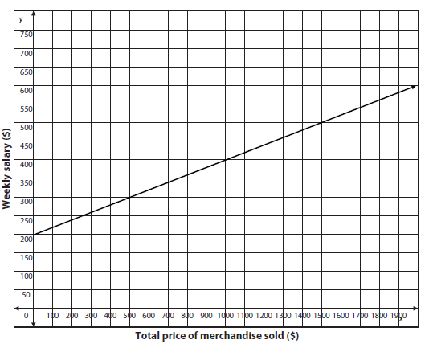
First Option

y-intercept:

slope:

Second Option

y-intercept:

slope:
a. Which function has a higher starting salary and why? b. Which function has a greater commission rate
and why?

2. Compare the properties of the functions below in terms of the problem situation:
Rental Store B
The table below shows the total cost in dollars to rent a steam cleaner at a different rental store, g(x) represents the total cost after x hours.
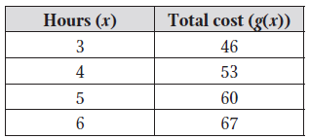
Rental Store A
A rental store charges $40 to rent a steam cleaner, plus an additional $4 per hour.

a. Which function has a higher staring price and why?

b. Which function has a higher rental cost per hour
and why?

3. Compare the properties of the functions below in terms of the problem situation:
Job Offer B
She received a second job offer represented by the following equation:
f(x) = 30,000(1+ 0.02)^{x}.
Job Offer A
Jazlynn received a job offer with a starting salary of $32,000 and a 1.5% increase every year.

a. Which function has a higher staring salary and why? b. Which function has a greater pay increase rate
and why?

4. Compare the properties of the functions below in terms of the problem situation:
Harrison High School
The following table shows the enrollment of Harrison High School, g(x), after x years.
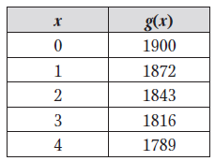
Allatoona High School
The enrollment of Allatoona High School, f(x), after x years is modeled by the function f(x) = 1700(1 + 0.025)^{x}.

a. Which school has a higher staring population and why?

b. Which function has a greater enrollment rate and why?

5. Three turtles are running a race. The following are their information from the starting line in t number of minutes.
Elmer:
Fred:
x | 1 | 2 | 3 | 4 | 5
G(t) | -18 | -20 | -18 | -12 | -2

George:

a. Which turtle is winning the race at t = 2?

b. Which turtle is winning the race at t = 6?

c. Who would you predict to win the race if the race was 40 feet long and why?

6. Three students are shooting wads of paper with a rubber band, aiming for a trash can in the front of the room. The height of each student’s paper wad, in feet, is given as a function of the time in seconds. Which student’s paper wad flies the highest?

- The path of Micaiah’s paper was is modeled by the equation f(x) = -x² + 2x + 7
- After 3 seconds, Trey’s paper wad achieves a maximum height of 6.5 feet above the floor.
- Quincy’s paper wad is estimated to reach the heights shown in the table below.
