Day 10: Comparing Functions Name: ____________________________
Practice Assignment Block: _______

1. Deidre and Beth each deposit money into their checking accounts weekly. Their account information for the past several weeks is shown below.
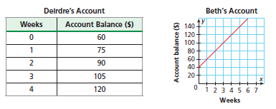

a. Compare the slopes and y-intercepts and interpret those values in context of the situation.
 | Deidre | Beth | Interpret and Compare
Slope
Y-intercept

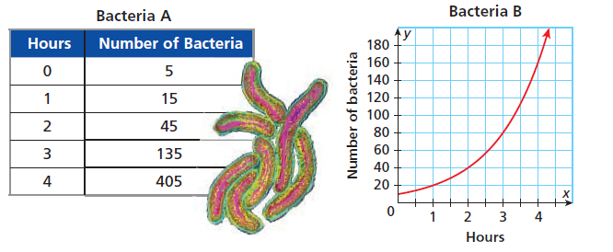
2. A biologist tracked the hourly growth of two different strains of bacteria in the lab. Here data are shown below. Compare the number of bacteria by finding the rate of change (percent of growth). Which bacteria is growing faster?

3. Kevin and Darius each hiked a different mountain trail at different rates as shown below. Compare the hikes by finding and interpreting the slopes and y-intercepts in context of the situation.
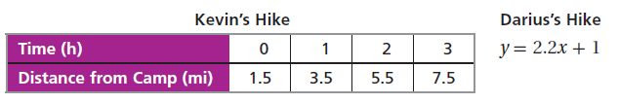
 | Kevin | Darius | Interpret and Compare
Slope
Y-intercept

4. Maddy and Savannah both had to have repairs done on their cars after they were in a fender bender with each other. The table and graph below show the remaining balance in dollars, f(x), of the cost of car repairs after x months. Who had the higher costs for repair and who is repaying their balance faster?

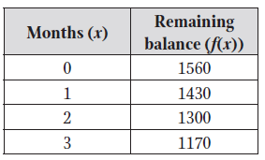
Maddy: Savannah:
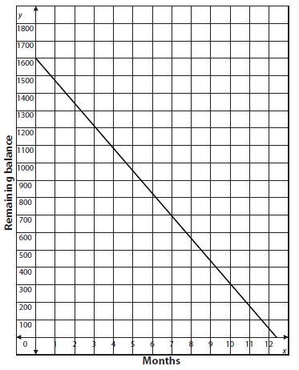

5. Which quadratic function has the lower minimum value? Explain why.
X | -4 | -3 | -2 | -1 | 0 | 1
y | 0 | -5 | -8 | -9 | -8 | -5
Function A. Function B.

6. Which quadratic function has the bigger y-intercept? Explain why.
Function A: y = -x² + 3x + 8 Function B:
X | -4 | -3 | -2 | -1 | 0 | 1
y | 9 | 13 | 19 | 13 | 9 | 7

7. For the following equations, determine for what x-values g(x) exceeds f(x).

a. f(x) = 2x + 3 and g(x) = x²

b. f(x) = 3x² and g(x) = 2^{x}

c. f(x) = 1.9^{x} and g(x) = 0.8(2)^{x}

8. Use the graph below to answer the following questions:
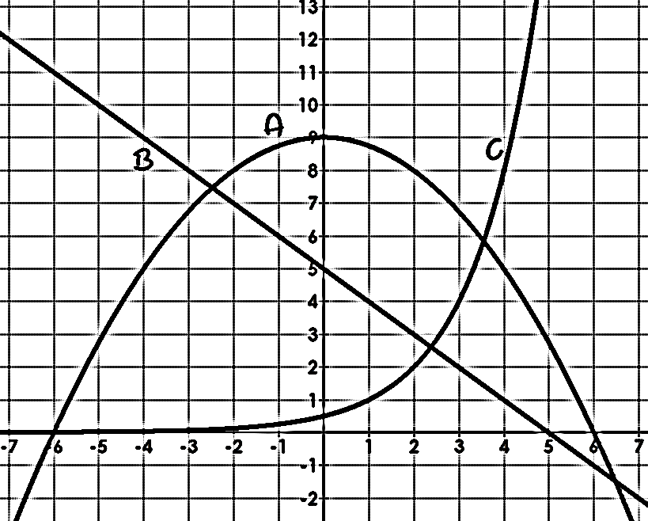
a. List the functions in order from least to greatest for y-intercepts:

b. Which function has the largest x-intercept?

c. List the functions in order from smallest to largest when x = -4.

d. List the functions in order from smallest to largest when x = 0.

e. List the functions in order from smallest to largest when x = 2.

f. List the functions in order from smallest to largest when x = 5.

g. Which graphs has the largest rate of change on the interval [-5, -3]?

h. Which graph has the largest rate of change on the interval [4, 5]?

