Algebra 1 Name: ________________________________
Cumulative Exam 7.1-8.2 Review Date:_________ Block: ________

Section 1: Perform the indicated operation.
1. 2. 3. (x – 9)(x + 6)

4. (x + 4)² 5. (6x + 3)(4x – 8) 6. Find the area & perimeter:
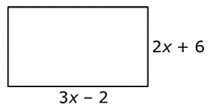

Section 2: Factor the following expressions:
7. x² – 12x 8. x² – 15x + 44

9. 2x² + 9x + 4 10. x² – 9

11. 6x² – 54x + 48 12. 6x² + 8x – 8

13. x² + 5x – 36 14. 2y² – 8y

15. 2x² + 20x + 48 16. 25x² – 9

Section 3: Describe the characteristics:
17.
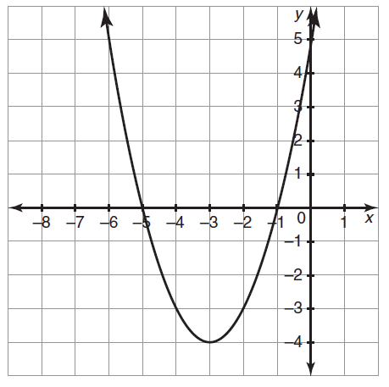

Domain: ___________________ Range: ______________________

Vertex: ____________________ Axis of Sym.__________________

Y-Intercept: ________________ Zeroes: ______________________

Extrema: ___________________ Max/Min Value: _____________

End Behavior: As x -∞, f(x) ______. As x ∞, f(x) ______

18.
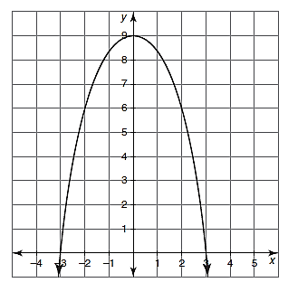

Domain: ___________________ Range: ______________________

Vertex: ____________________ Axis of Sym.__________________

Y-Intercept: ________________ Zeroes: ______________________

Extrema: ___________________ Max/Min Value: _____________

End Behavior: As x -∞, f(x) ______. As x ∞, f(x) ______

Section 4: Answer the following questions about transformations:
19. Describe the transformations and name the vertex: y = -2(x + 3)² – 9

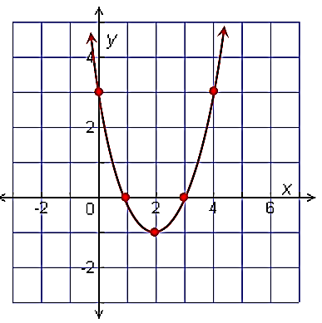
20. Describe the transformations from y = x² to the graph at the right:

21. Create an equation to describe the following transformations:
a. Opens down, shifts up 3 units and shrinks by ¼ b. Shifts left 7 and reflects across the x-axis

Section 5: Answer the following questions about parabolas and their characteristics:
22. Determine the form and associated characteristics: y = 2(x + 4)(x – 3)

23. Determine the form and associated characteristics: y = (x – 5)² + 9

24. Determine the form and associated characteristics: y = -x² + 6x – 1

25. Convert y = (x + 3)(x – 8) to standard form. What new characteristic can you give?

26. Convert y = x² – 5x – 24 to factored form. What new characteristic can you give?

27. Convert y = x² + 6x + 4 to vertex form. What new characteristic can you give?

28. Convert y = (x + 2)² – 5 to standard form. What new characteristic can you give?

29. Write an equation to describe the following characteristics:
a. x-intercepts of (7, 0) and (-2, 0) and graph opens up b. Vertex of (-5, -2) and graph has a maximum

30 Write an equation in vertex, factored, and standard form to describe the following graphs:
a. b.
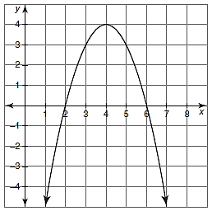
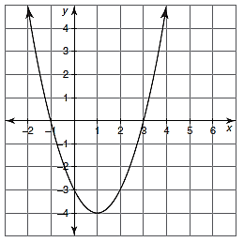

Vertex Form: Vertex Form:

Intercept Form: Intercept Form:

Standard Form: Standard Form:

