Correlation Coefficient Matching Practice
Directions: For each scatterplot below, match the corresponding correlation coefficient. Then describe the type AND strength of the correlation.
Answer Choices:
A. r = 0.96 B. r = -0.41 C. r = 0.53

D. r = -1 E. r = -0.02 F. r = -0.55

G. r = -0.97 H. r = 1 I. r = -0.92

1.  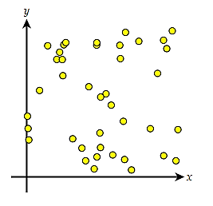 | 2.  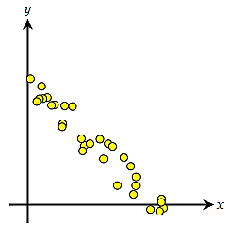 | 3.  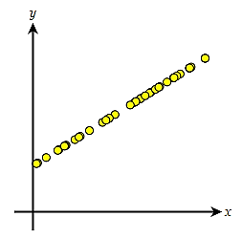
4.  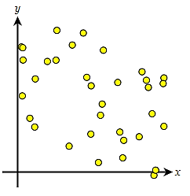 | 5.  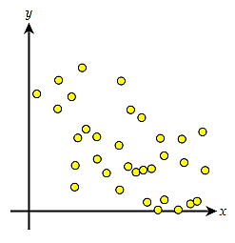 | 6.  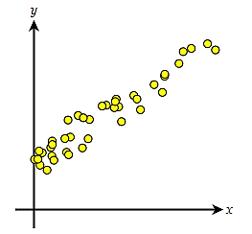
7.  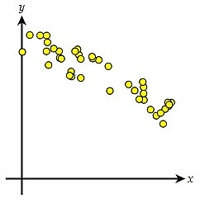 | 8.  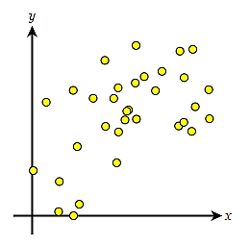 | 9.  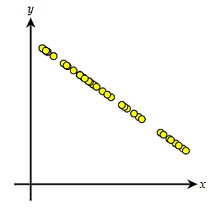
Correlation Coefficient Matching Practice

Match the following graphs with their corresponding correlation coefficient value:

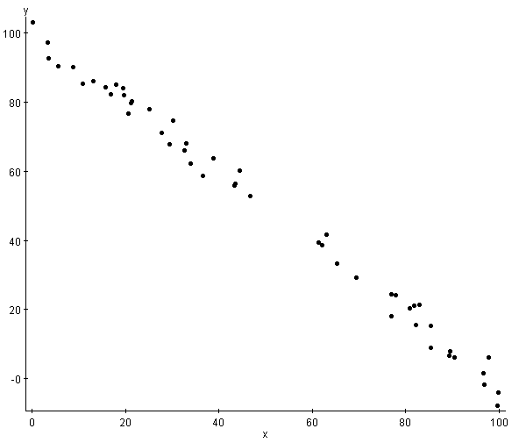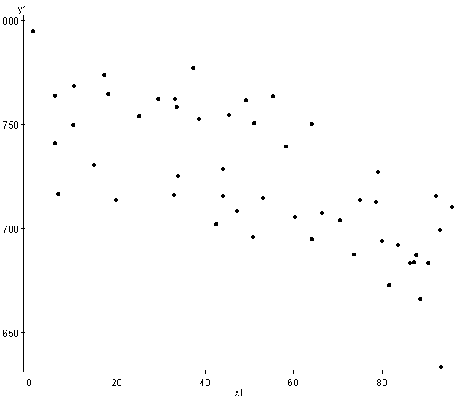
1 2
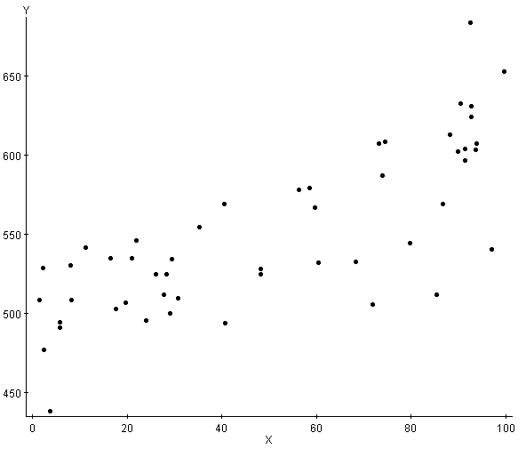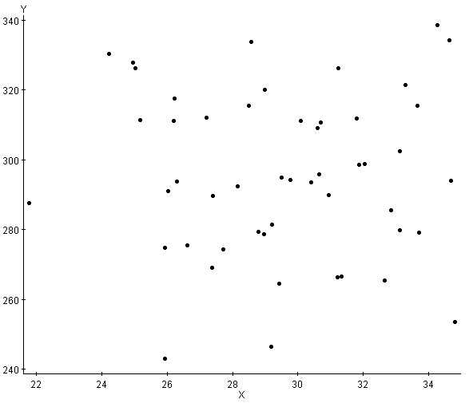
- 4

Graph ___ has a correlation coefficient of -0.015 between the two variables.

Graph ___ has a correlation coefficient of -0.996 between the two variables.

Graph ___ has a correlation coefficient of 0.778 between the two variables.

Graph ___ has a correlation coefficient of -0.728 between the two variables.

Correlation Coefficient Matching Practice

Match the following graphs with their corresponding correlation coefficient value:
Answer Choices:
A. r = -0.99 B. r = 0.5 C. r = -0.3

D. r = 0 E. r = -0.7 F. r = 0.9

1. 2. 3.

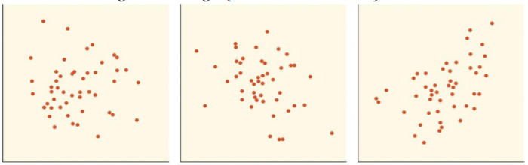

4. 5. 6.

