Comparing Functions Notes Name: _________________________________
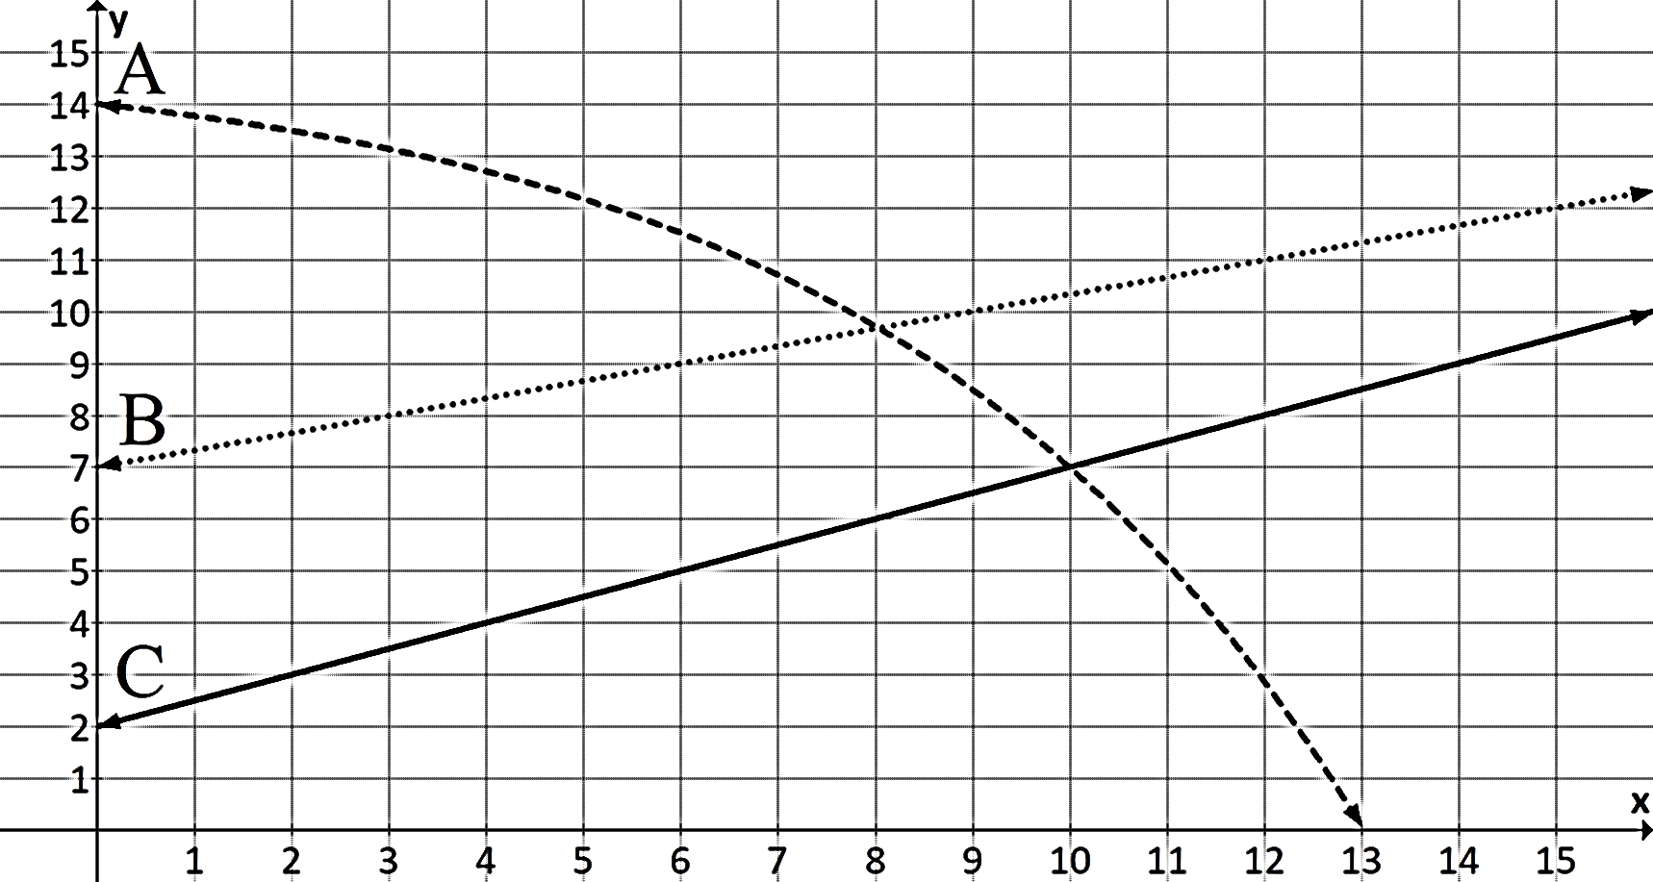
Use the following graph to answer the following questions:

List the functions in order from smallest to largest based on x-intercepts:
List the functions in order from smallest to largest based on y-intercepts:
List the functions in order from smallest to largest when x = 2:
List the functions in order from smallest to largest when x = 9:
List the functions in order from smallest to largest when x = 11:
List the functions in order from smallest to largest when x = 40:
Which functions have a positive rate of change through the entire graph?
Which functions have a negative rate of change through the entire graph?
Which function has a rate of change that can be both positive and negative?
Which functions go towards negative infinity as x goes towards infinity?
Which functions go towards positive infinity as x goes towards infinity?
Between what values of x is function A the largest? Write in interval notation.
Between what values of x is function B the largest? Write in interval notation.
Between what values of x is function C the largest? Write in interval notation.

